

**IdleGenie**

**Idle time Tracking and Everyday Interaction with Personal Intelligences**

Course Code: **CSE428**

Course Title: Human Computer & Interaction

Section: **01**

Submitted to

**Yasin Sazid**

Lecturer

Department of Computer Science and Engineering

**Submitted by**

|  |  |
| --- | --- |
| **Name** | **Student ID** |
| B.M Sahria Alam | 2021-3-60-016 |
| Tamanna Islam | 2021-3-60-125 |
| Shekh Maruf | 2021-3-60-157 |
| Golam Kibria | 2021-3-60-215 |

Submission Date: 22nd May, 2025

**Declaration Page:**

We, the undersigned, declare that this project report is a result of our own work and that all external sources have been duly acknowledged.

|  |  |
| --- | --- |
|  | Signature |
|  | ……………………………….…  (Golam Kibria)  (ID:2021-3-60-215) |
|  | ……………………………….…  (Shekh Maruf)  (ID: 2021-3-60-157) |
|  | ……………………………….…  (B. M. Shahria Alam)  (ID: 2021-3-60-016) |
|  | ……………………………….…  (Tamanna Islam)  (ID: 2021-3-60-125) |

**Table of Contents:**

Chapter 1: Introduction 1

1.1 Project Theme 1

1.2 Project Overview 1

1.3 Objectives and Scope 1

1.3.1 Objectives 1

1.3.2 Scope 2

1.4 Stakeholders 2

Chapter 2: Low Fidelity Sketching 3

2.1 Process 3

2.2 Sketch Themes 3

Chapter 3: Background Study 11

3.1 Research Papers 11

Chapter 4: User Research 12

4.1 Research Questions Development 12

4.2 Interview Questionnaire 12

4.3 Alternate Research Method 13

4.4 Data Collection 14

4.5 Findings 14

Chapter 5: High Fidelity Prototyping 30

5.1 Figma Prototype URL 30

5.2 Style Guide: 42

Chapter 6: Interface Evaluation 47

6.1 Heuristic Evaluation 47

Chapter 7: Conclusion 56

Appendices 57

Appendix A: Survey Responses 57

Appendix B: Sketches and Wireframes 57

Appendix C: Figma Prototype Screenshots 58

**Table of Figures:**

1 Fig 2.1: Idle Time Dashboard 4

2 Fig 2.2: Distraction Tracker 5

3 Fig:2.3 Settings 6

4 Fig:2.4 Gamified and Reward Productivity Panel 6

5 Fig 2.5: Activity Interface and Distraction Tracker P 8

6 Fig 2.6: Gamification and Setting 9

7 Fig 4.1: Pie chart that shows the distribution of smartphone usage based on the average number of hours spent on a smartphone per day. 14

8 Fig 4.2: Bar graph showing the results of a survey about the apps people spend most of their time on 15

9 Fig 4.3: Pie chart illustrating the responses to the question: "Do you feel guilty or regretful after spending too much time on your phone?" 17

10 Fig 4.4: Pie chart displaying the responses to the question: "Have you used any screen time tracking or productivity apps before?" 19

11 Fig 4.5: Bar chart showing the types of activities respondents consider meaningful during short free time windows. 21

12 Fig 4.6: Pie chart showing the responses to the question: "Would you like your app to give you gentle nudges when you are spending too much time on 'mindless' activities?" 23

13 Fig 4.7: Bar chart showing the preferred formats for learning during short sessions. 24

14 Fig 4.8: Pie chart showing the responses to the question: "How open are you to personalized suggestions based on your app usage behavior?" 26

15 Fig 4.9: Pie chart showing the responses to the question: "Would you recommend such an app to others if it helped you use your time better?" 28

16 Fig 5.1: Overview of all pages 30

17 Fig 5.2: Login Page 31

18 Fig 5.3: Create Account Page 32

19 Fig 5.4: Home Page 33

20 Fig 5.5: My Profile Page 34

21 Fig 5.6: Edit My Profile Page 35

22 Fig 5.7: My Group Page 36

23 Fig 5.8: My Community Page 37

24 Fig 5.9: Distraction Page 38

25 Fig 5.10: Setting Page 39

26 Fig 5.11: My Activity Page 40

27 Fig 5.12: Game Page 41

28 Fig 5.13: Leaderboard Page 42

29 Fig 5.14: Style Guide Fontd and Colors. 43

30 Fig 5.15: Navigation Bar 44

31 Fig 5.16: Screen Scroll Component 45

32 Fig 5.17: Leaderboard Components 45

33 Fig 5.18: All Components 46

34 Fig 6.1: Home page 47

35 Fig 6.2: Distraction page 48

36 Fig 6.3: My activity page 49

37 Fig 6.4: My activity page 50

38 Fig 6.5: Game page 51

39 Fig 6.6: Leaderboard page 52

40 Fig 6.7: Setting page 53

41 Fig 6.8: My profile page 54

42 Fig 6.9: My Group page 55

# Chapter 1: Introduction

## 1.1 Project Theme

This project focuses on a Smart AI-based idle time tracking system, presented in the form of an application called IdleGenie. The primary objective of IdleGenie is to improve user productivity, mental well-being, and provide entertainment during periods of inactivity or brief distractions. By leveraging AI-powered detection and recommendation systems, the application identifies idle moments and suggests meaningful ways to utilize that time effectively, turning otherwise unproductive moments into valuable experiences.

## 1.2 Project Overview

**IdleGenie** tracks moments when users are idle or distracted on their devices and offers personalized activity suggestions based on their preferences. It can detect periods of inactivity and recommend tasks that support productivity, well-being, or entertainment. These suggestions are tailored using insights from the user's past behavior and interactions with the app. By making idle time more purposeful, IdleGenie encourages positive habits and helps reduce time that might otherwise be unproductive.

In addition, the system aims to tackle the issue of excessive screen time by encouraging users to take productive breaks or participate in healthy activities like stretching, mindfulness exercises, or short educational tasks.

## 1.3 Objectives and Scope

### 1.3.1 Objectives

* **Enhance Digital Well-being**: The application promotes healthier digital habits by offering alternatives during idle moments.
* **Utilize Downtime Intelligently**: IdleGenie ensures that time spent away from focused tasks is used for growth, entertainment, or relaxation.
* **Track and Reduce Distractions**: The application identifies micro-distractions that hinder productivity and suggests ways to mitigate them.

### 1.3.2 Scope

The scope of this project includes the design, development, and testing of the IdleGenie application. It covers various phases such as:

1. Conceptualization and sketching.
2. Prototyping (low-fidelity and high-fidelity).
3. User research and testing.
4. Interface evaluation.

The implementation will focus on developing an intuitive user interface (UI) and ensuring that the system operates smoothly across different devices (mobile, tablet).

## 1.4 Stakeholders

* **End Users**: Students, professionals, and anyone seeking to improve their productivity and reduce idle screen time.
* **Developers**: Engineers and UI/UX designers responsible for building and refining the application.
* **Mental Wellness Professionals**: Experts who help guide the design decisions to ensure the application promotes mental and emotional well-being alongside productivity.

# Chapter 2: Low Fidelity Sketching

## 2.1 Process

The low-fidelity sketching process involved several stages:

1. **Paper Sketches**: The initial brainstorming was done on paper, where rough sketches were created to explore different design ideas such as dashboards, menus, and activity suggestions.
2. **Digital Mockups**: After selecting the most promising paper sketches, they were transformed into digital wireframes using design tools like Figma.
3. **User Feedback & Iteration**: These early wireframes were then shared with peers and potential users to gather feedback. Based on their input and observations related to usability and clarity, the designs were improved through several iterations.

## 2.2 Sketch Themes

The sketches covered several critical aspects of the user interface, which helped us visualize how the final application would appear. Key themes included:

1. **Idle Time Dashboard**: A dashboard displaying the user's idle time in real-time, alongside suggested activities to make the most of that time.
2. **Activity Interface**: Interface elements displaying suggested activities for users, such as productivity tasks, wellness exercises, or entertainment.
3. **Distraction Tracker**: A tool that monitors distractions and provides insights into when and how the user is deviating from productive activities.
4. **Gamified Productivity Panel**: A section of the application that integrates gamification elements to make tracking productivity more engaging (e.g., progress bars, rewards).
5. **My Profile Dashboard**: A personalized profile page where users can track their goals, history, and achievements.
6. **My Community Dashboard**: A social feature that allows users to see how others are managing their idle time, fostering community support and friendly competition.

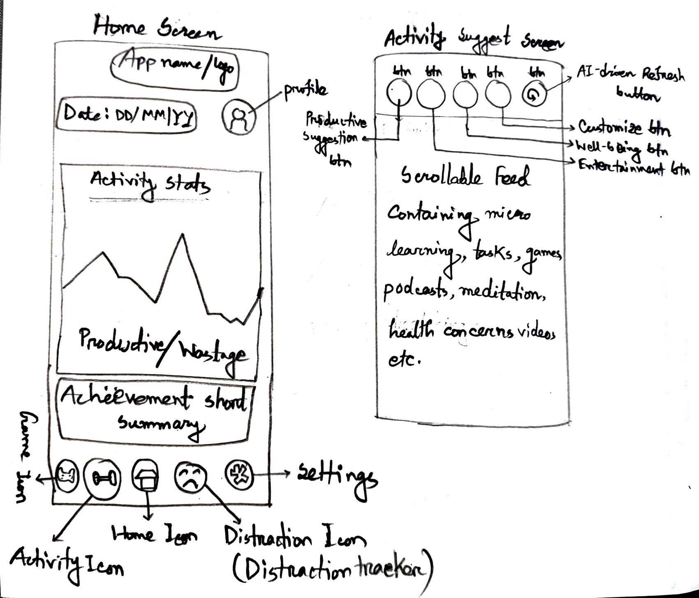

1 Fig 2.1: Idle Time Dashboard

Fig 2.1: Idle Time Dashboard

**1. Home Screen and Activity Suggestion Screen (First Image)**

* **Home Screen:**
  + The home screen provides an overview of the user's app activity. The screen includes:
    - **Activity Stats**: Displayed as a graph, showing the user's productivity or wasted time.
    - **Achievement Summary**: A small summary that shows the user’s progress or achievements, like completing tasks.
    - **Productivity/Usage Stats**: A section showing the user’s productivity stats and time usage.
    - **Date Section**: Displays the current date and any notifications related to app activity.
    - **Icons for Different Sections**: Includes icons for the home, activity, and distraction tracker sections.
* **Activity Suggestion Screen:**
  + A **scrollable feed** featuring various content types like:
    - **Micro Learning**: Suggests brief learning activities like tasks, games, podcasts, or meditation.
    - **Health Concerns Videos**: Suggests health-related videos for quick, meaningful engagement.
    - Users can customize the feed based on their preferences (e.g., focus, entertainment, or wellness).

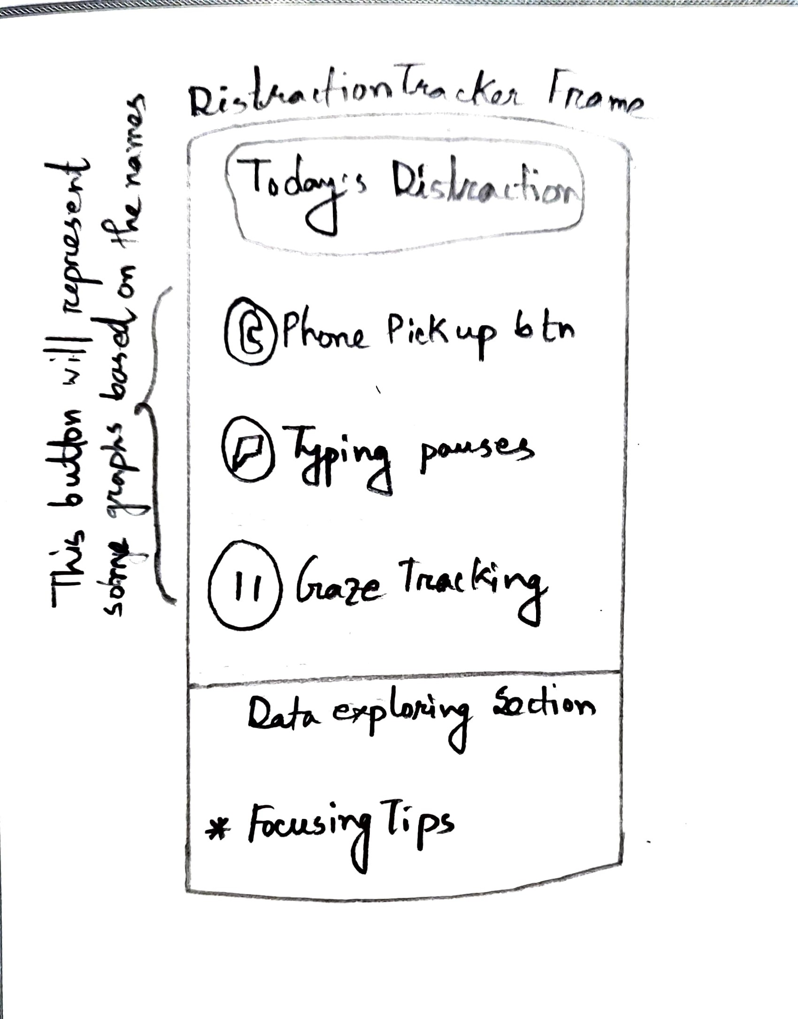

2 Fig 2.2: Distraction Tracker

Fig 2.2: Distraction Tracker

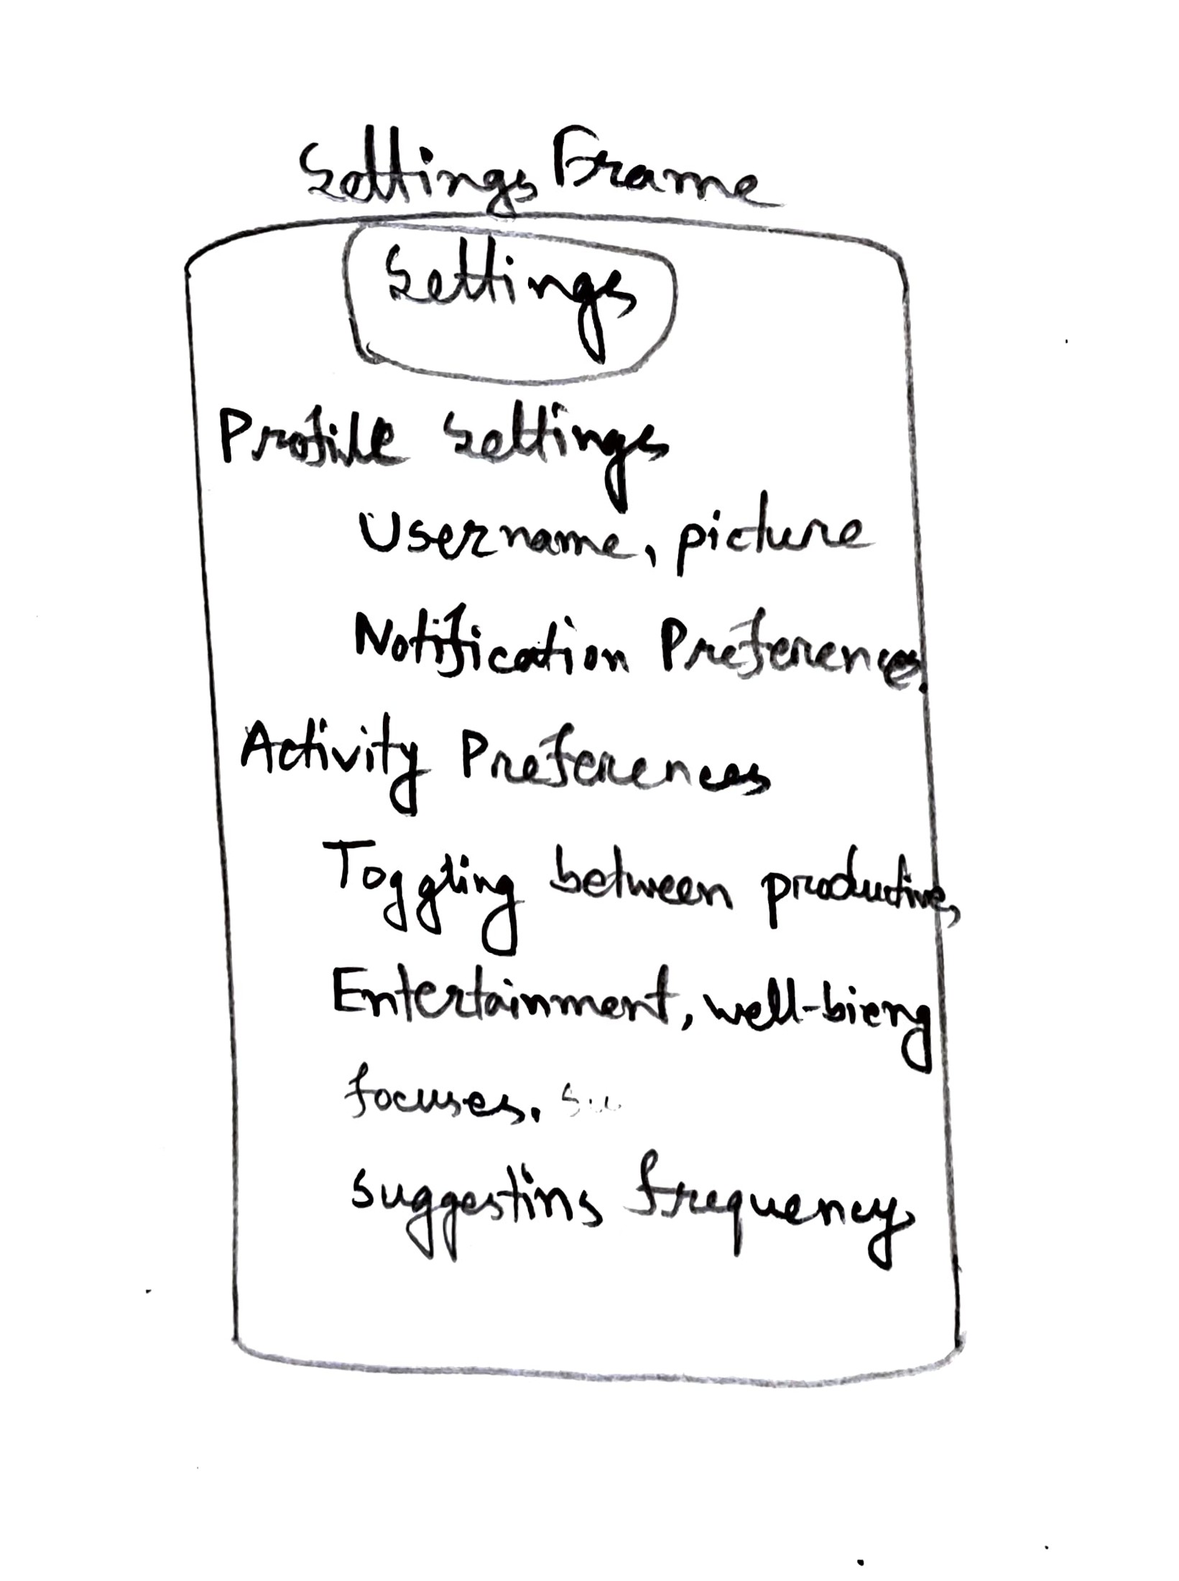

3 Fig:2.3 Settings

Fig:2.3 Settings

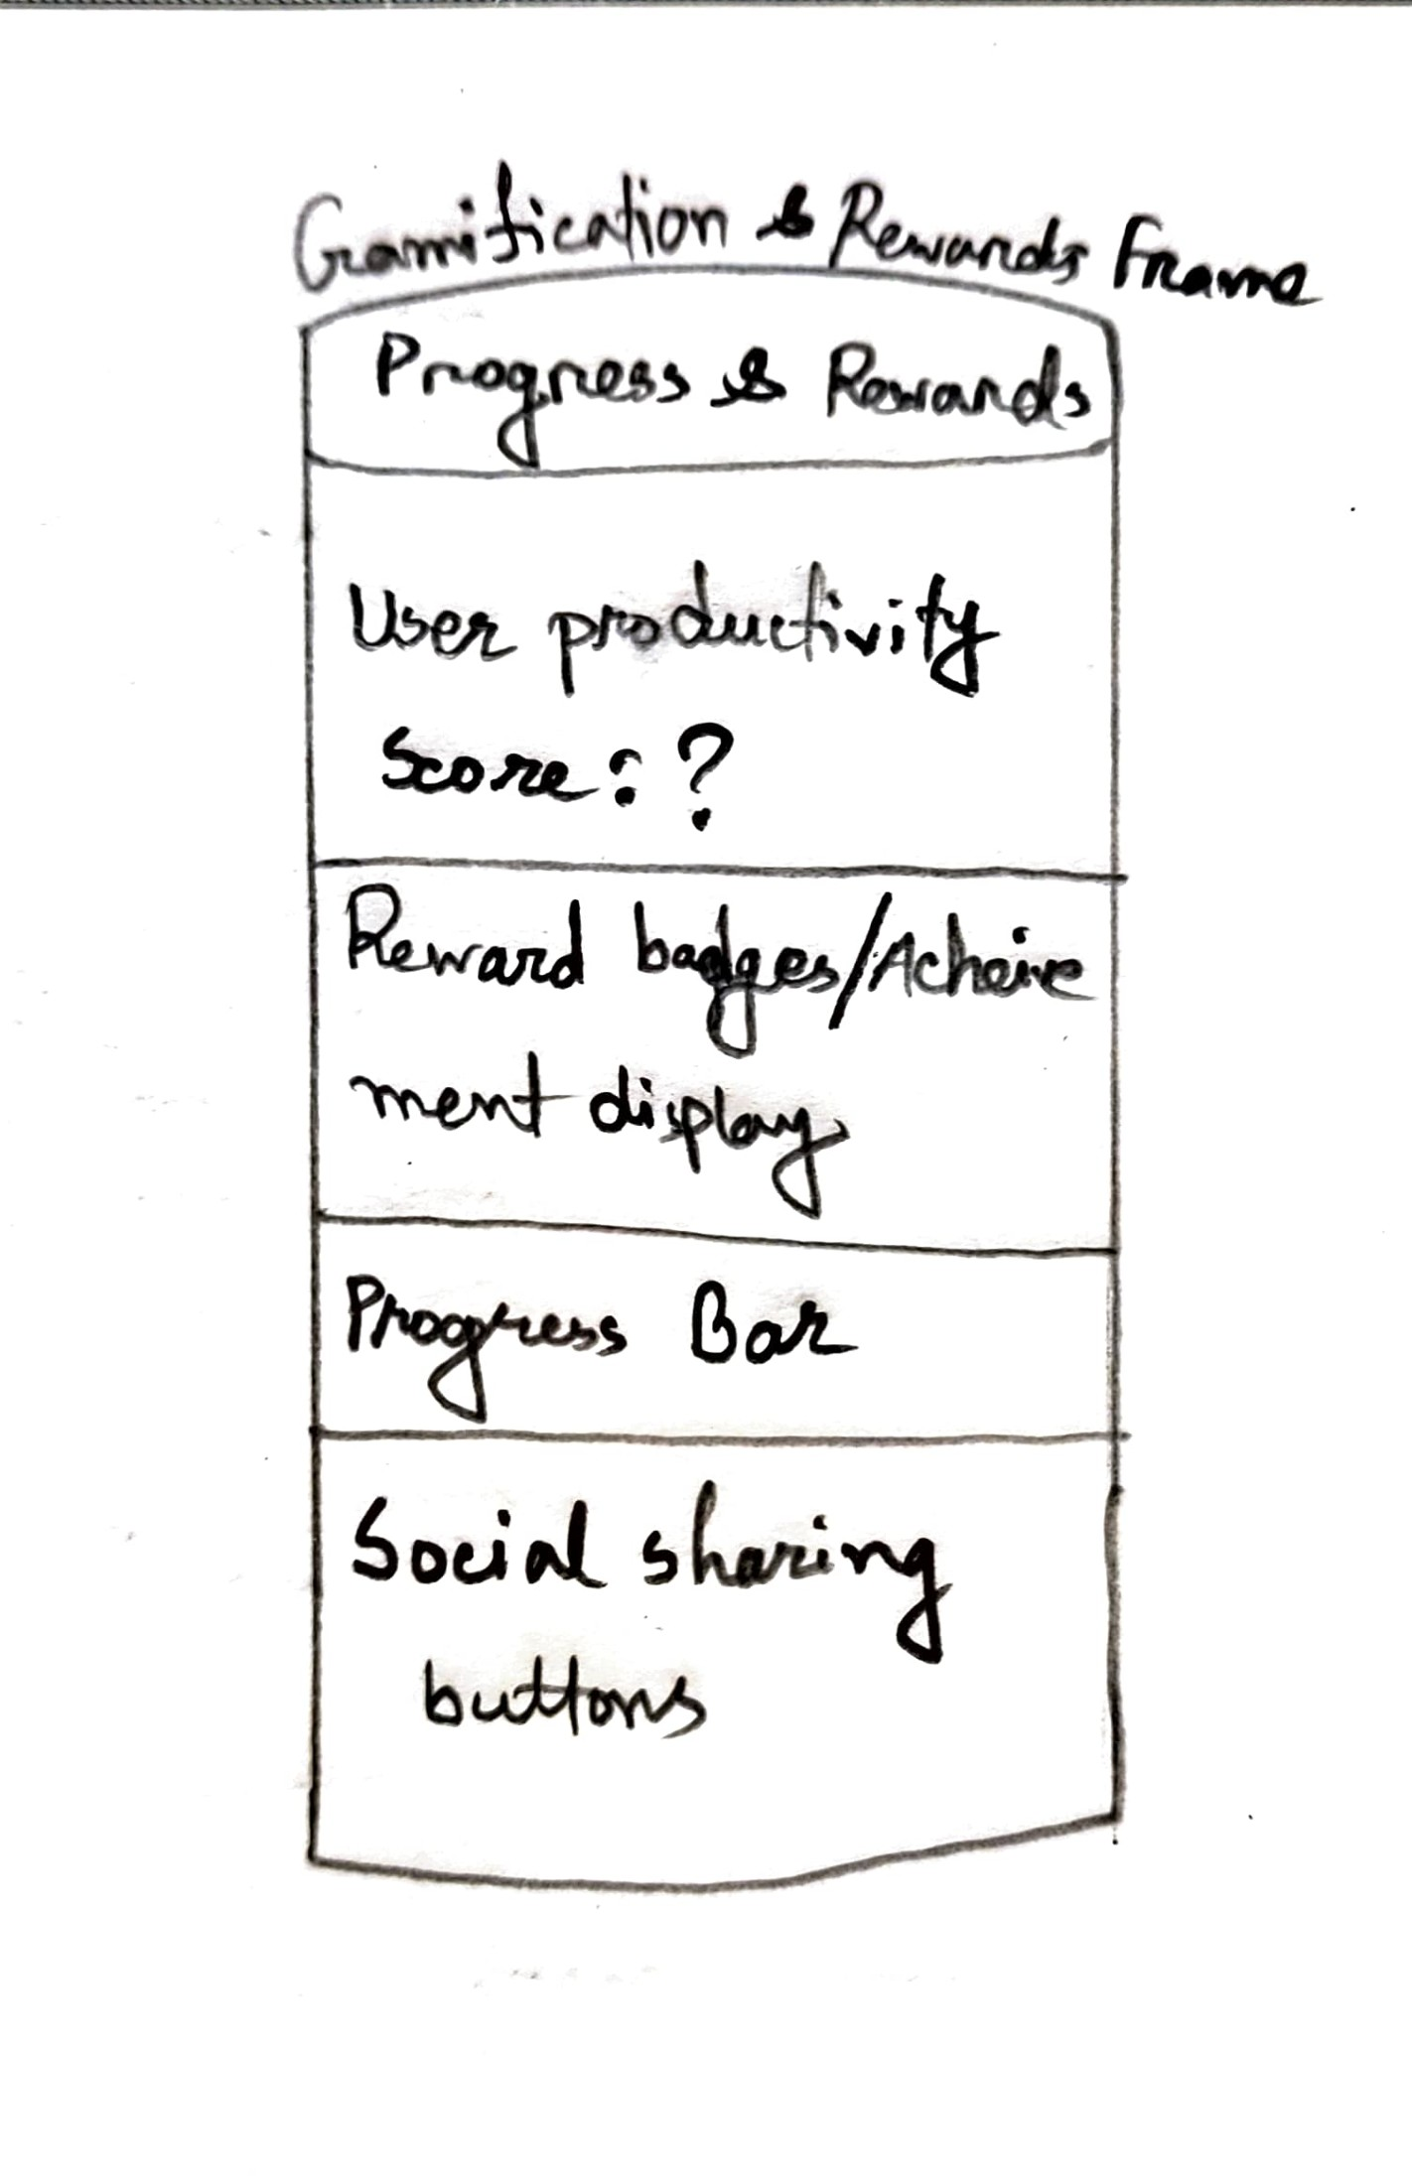

4 Fig:2.4 Gamified and Reward Productivity Panel

Fig:2.4 Gamified and Reward Productivity Panel

**2. Distraction Tracker Frame (Second Image)**

* **Distraction Tracker**:
  + **Today's Distractions**: A section listing various distractions the user faced during the day, including:
    - **Phone Pickup**: Tracks the number of times the user picks up their phone.
    - **Typing Pauses**: Monitors pauses in typing to identify distractions.
    - **Gaze Tracking**: Analyzes eye movement to determine if the user is distracted.
  + **Data Explaining Section**: Provides insights into the user’s distraction patterns and gives focusing tips.
  + **Patterns & Insights**: Presents a graphical view of how distractions are impacting productivity.

**3. Settings Frame (Third Image)**

* **Settings Frame**:
  + **Profile Settings**: Allows users to set or update their username and profile picture.
  + **Notification Preferences**: Lets users customize notification settings for reminders and suggestions.
  + **Activity Preferences**: Users can toggle between various activity categories (e.g., productive tasks, entertainment, wellness) and set suggestion frequencies.
  + These settings allow users to tailor the app experience according to their needs.

**4. Gamification & Rewards Frame (Fourth Image)**

* **Progress and Rewards**:
  + **User Productivity Score**: Displays a productivity score based on tracked activities.
  + **Reward Badges**: Users earn badges or achievements based on their productivity and engagement.
  + **Progress Bar**: Shows a visual representation of the user’s current progress toward goals.
  + **Social Sharing Buttons**: Users can share their achievements or progress on social media.

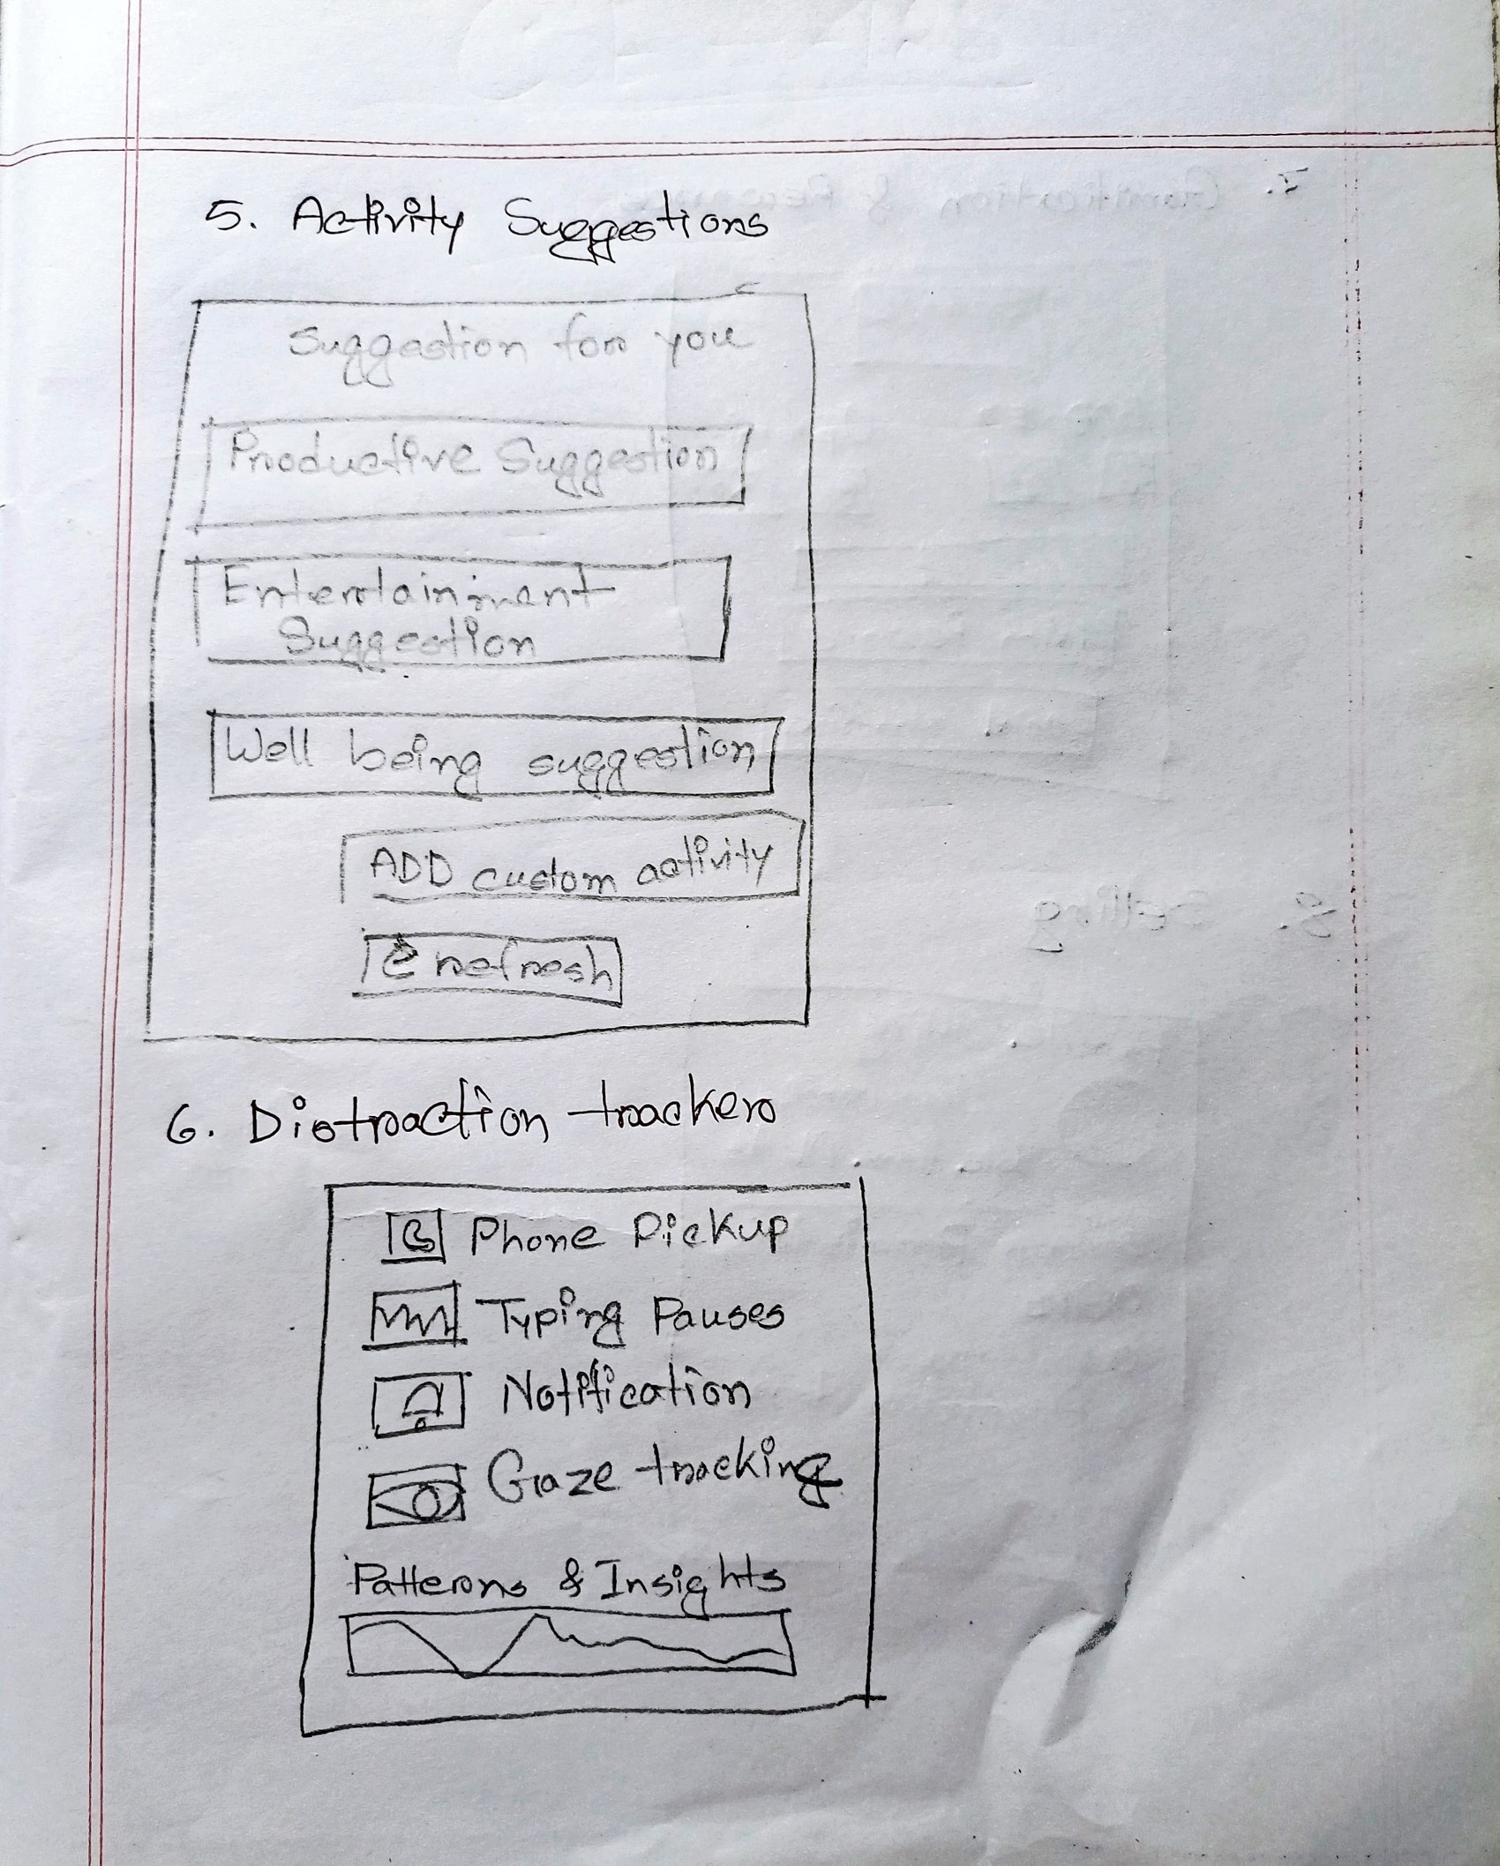

5 Fig 2.5: Activity Interface and Distraction Tracker P

Fig 2.5: Activity Interface and Distraction Tracker Panel.

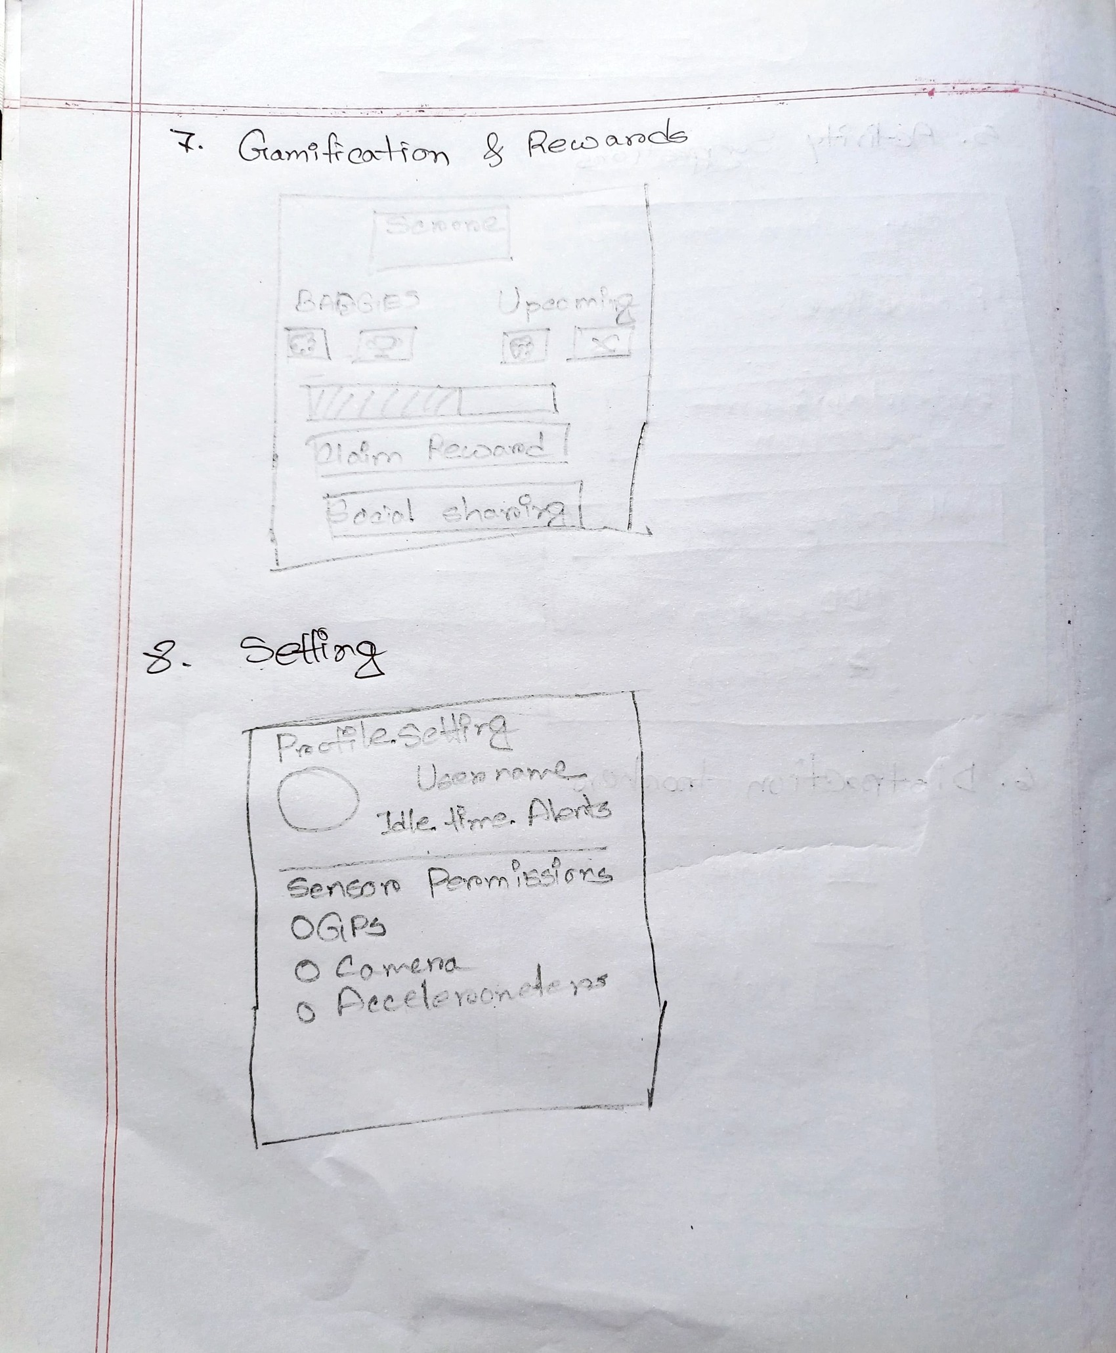

6 Fig 2.6: Gamification and Setting

Fig 2.6: Gamification and Setting

**5. Activity Suggestions and Distraction Tracker (Fifth Image)**

* **Activity Suggestions**:
  + **Suggestions for You**: The app suggests personalized tasks for the user, categorized into:
    - **Productive Suggestions**
    - **Entertainment Suggestions**
    - **Well-being Suggestions**
  + **Add Custom Activity**: Allows the user to add their own custom activities.
* **Distraction Tracker**:
  + A dedicated section to track specific distractions such as phone pickup, typing pauses, notifications, and gaze tracking. Patterns and insights are visualized here as well.

**6. Gamification & Rewards and Settings (Sixth Image)**

* **Gamification & Rewards**:
  + The rewards section from earlier, now further refined. It emphasizes progress and user engagement with the productivity score and reward badges.
* **Settings**:
  + The settings section from the previous sketches, now emphasizing additional options like enabling GPS, camera, and accelerometer permissions. This suggests that the app may use these sensors to track user activity for more detailed feedback.

**7. Additional Features**

* **Settings and Customizations**:
  + The final design also shows user profile settings, preferences for notifications, and other preferences that personalize the app experience.

These sketches outline the key features and flow of the app, highlighting the integration of tracking tools, activity suggestions, and gamification elements to encourage user engagement and productivity management. Let me know if you need more detail or further refinement!

# Chapter 3: Background Study

## 3.1 Research Papers

The development of this project was significantly informed by the research paper titled “Human-AI Interaction in Regulating Productivity and Wellbeing” by Talitakuum Ekandjo. This study explored the evolution of self-tracking technologies and their integration with AI to manage personal productivity and digital well-being. One of the key areas discussed in the paper was attention modeling. It highlighted how AI can track various user behaviors such as screen time, app usage, task-switching, and even subtle actions like cursor movement to identify distractions and predict moments of low focus. These capabilities align directly with the goals of our system, which aims to detect idle or mindless phone use and provide meaningful engagement suggestions.

The paper also examined the role of AI-based productivity tools, using Microsoft Viva as a notable example. Such tools utilize artificial intelligence to monitor daily user patterns and provide personalized feedback or recommendations to help optimize time and improve focus. Inspired by this approach, our system incorporates similar logic in its suggestion engine prompting users with micro-tasks, learning modules, or well-being activities based on their interaction history and behavior trends.

Furthermore, the research emphasized the importance of digital well-being in AI systems. Rather than promoting constant productivity, the paper advocated for a balance between work and rest, suggesting features like emotional check-ins, mindfulness reminders, and scheduled breaks. These ideas shaped our decision to include wellness-oriented features alongside productivity suggestions, ensuring the user experience remains supportive rather than overwhelming. Overall, this background study provided a strong theoretical foundation for the design and objectives of our project.

# Chapter 4: User Research

## 4.1 Research Questions Development

**Research Question 1**

* **How do students and active users perceive and manage idle time on phones?**
* **Motivation**: This question aims to understand whether users view idle time as wasted or an opportunity for relaxation.
* **Participant Info to Collect**: Daily screen time, most-used apps, and perceptions about idle time.
* **Design Implication**: This will guide the design of a feature that tracks idle moments and offers gentle, non-intrusive reminders for productive tasks.

**Research Question 2:**

* **What types of content do users find valuable during their free time, and how open are they to guided microlearning or productivity nudges?**
* **Motivation**: To create an engaging system, we need to understand what content is most beneficial and how users feel about being nudged by the app.
* **Participant Info to Collect**: Preferences for content types (videos, quizzes, short reads) and openness to productivity nudges.
* **Design Implication**: This will inform personalized content suggestions and the design of non-intrusive notifications.

## 4.2 Interview Questionnaire

For each research question, we developed detailed, open-ended interview questions designed to elicit insightful responses:

**Questions Supporting Research Question 1:**

1. Can you describe how much time you typically spend on your phone in a day? What are your top three most-used apps?

Goal: Understand actual usage patterns

2. When do you feel like you are wasting time on your phone? What triggers that feeling?

Goal: Identify subjective perception of “wasted time”

3. Have you ever tried to limit your screen time or track your device usage? What tools or methods did you use, if any?

Goal: Explore pain points with current tracking tools

4. Do you consider all non-work or non-study screen time as wasteful, or are there exceptions?

Goal: Explore user’s personal definitions of valuable vs. idle time

5. How would you feel if an app tracked your idle or mindless time and provided feedback? Would that motivate you or annoy you? Why?

Goal: Measure receptiveness to tracking and feedback mechanisms

Questions Supporting Research Question 2:

6. What kinds of activities do you enjoy doing in your free time when you are not working or studying?

Goal: Discover potential content types the app can recommend

7. Would you be open to short tasks or learning modules (1–5 mins) when you’re idle on your phone? Why or why not?

Goal: Assess openness to microlearning

8. If an app could suggest something educational or skill-based based on your interests, what type of suggestions would you prefer?

Goal: Understand interest-based personalization

9. What would make you trust an app to guide how you use your free time more wisely?

Goal: Uncover trust factors in design and content recommendations

## 4.3 Alternate Research Method

In addition to interviews, we could use surveys to reach a larger audience. Interview questions would be transformed into Likert-scale survey items to assess user preferences on a broader scale.

## 4.4 Data Collection

The data from three users revealed that:

1. Users are highly aware of their idle time but feel guilty about it.
2. Many users prefer short, engaging activities that are not forced but suggested based on interest.
3. The majority are open to receiving non-intrusive reminders to help them refocus.

## 4.5 Findings

We did some analysis on our collected data. The analysis are given below:

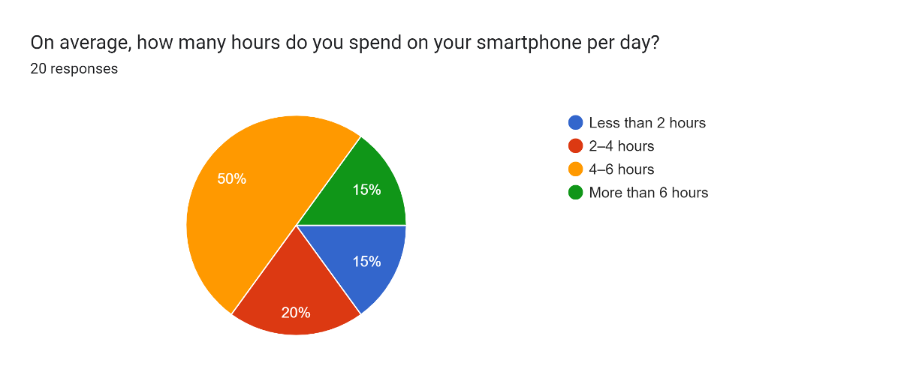

7 Fig 4.1: Pie chart that shows the distribution of smartphone usage based on the average number of hours spent on a smartphone per day.

Fig 4.1: Pie chart that shows the distribution of smartphone usage based on the average number of hours spent on a smartphone per day.

The chart you’ve provided is a pie chart that shows the distribution of smartphone usage based on the average number of hours spent on a smartphone per day, with 20 total responses. Here’s the analysis of the data:

**Analysis of Smartphone Usage Data:**

1. **Less than 2 hours (Blue):**
   * **15%** of participants spend less than 2 hours on their smartphone per day.
2. **2-4 hours (Red):**
   * **20%** of participants spend between 2 and 4 hours on their smartphone per day.
3. **4-6 hours (Orange):**
   * **50%** of participants spend between 4 and 6 hours on their smartphone per day.  
      This group represents the majority, indicating that a significant portion of users spends a considerable amount of time on their smartphones daily.
4. **More than 6 hours (Green):**
   * **15%** of participants spend more than 6 hours on their smartphone per day.

**Insights:**

* **Majority of users (50%) spend between 4-6 hours** on their smartphones, which suggests that smartphones play a central role in many people's daily routines, potentially for work, entertainment, and social interaction.
* **20% of users spend 2-4 hours**, indicating a moderate usage pattern.
* **15% of users spend less than 2 hours** on their smartphones, which could represent users with a more mindful or restricted usage pattern.
* **15% of users spend more than 6 hours**, possibly highlighting users who are highly dependent on their devices or may experience distraction from overuse.

The distribution suggests a significant reliance on smartphones for various activities, which could inform the design of apps or systems that help manage or optimize smartphone usage.

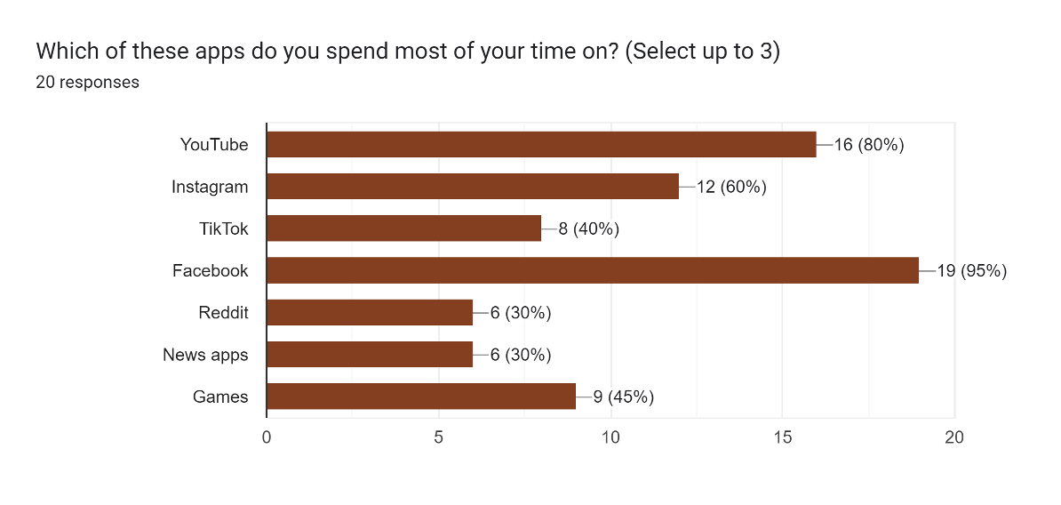

8 Fig 4.2: Bar graph showing the results of a survey about the apps people spend most of their time on

Fig 4.2: Bar graph showing the results of a survey about the apps people spend most of their time on

The chart you've provided is a bar graph showing the results of a survey about the apps people spend most of their time on, with a total of 20 responses. Here's a detailed analysis:

**Analysis of Time Spent on Apps:**

1. **YouTube (80%)**
   * **16 out of 20** respondents indicated that they spend most of their time on YouTube, making it the most popular app for this group.
   * This suggests that YouTube is a major platform for entertainment and content consumption among the respondents.
2. **Instagram (60%)**
   * **12 out of 20** respondents reported spending most of their time on Instagram.
   * Instagram, a social media platform known for photos, videos, and stories, is clearly another significant app for this demographic.
3. **TikTok (40%)**
   * **8 out of 20** respondents selected TikTok.
   * As a short-video app, TikTok is a strong contender for time spent on smartphones, indicating its rising popularity.
4. **Facebook (95%)**
   * **19 out of 20** respondents spend significant time on Facebook.
   * This makes Facebook the app with the highest engagement, reflecting its status as a dominant social media platform for personal connections, news, and entertainment.
5. **Reddit (30%)**
   * **6 out of 20** respondents reported spending time on Reddit.
   * Reddit is popular for its community-based content and discussions, though it does not rank as high as the other platforms in this survey.
6. **News Apps (30%)**
   * **6 out of 20** respondents use news apps.
   * This shows moderate usage, with respondents relying on news apps for current events and updates.
7. **Games (45%)**
   * **9 out of 20** respondents spend their time playing games.
   * Mobile games are a popular form of entertainment for many, though it's not as heavily used as social media platforms.

**Insights:**

* **Social Media Dominance**: **YouTube**, **Instagram**, and **Facebook** are the top contenders, showing that people spend most of their smartphone time on social media and content consumption platforms.
* **TikTok’s Rise**: The increasing percentage of users spending time on TikTok reflects the platform’s growing influence.
* **Gaming Engagement**: **Games** remain a substantial category, with almost half of the respondents engaged in gaming activities.
* **News Consumption**: While not as dominant, **News Apps** hold importance for a portion of users, reflecting a need for real-time information.

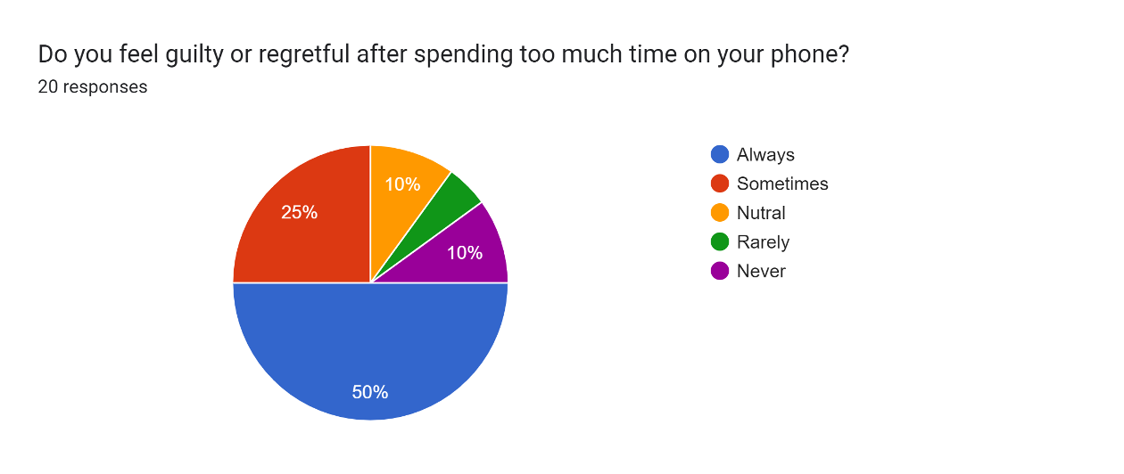

9 Fig 4.3: Pie chart illustrating the responses to the question: "Do you feel guilty or regretful after spending too much time on your phone?"

Fig 4.3: Pie chart illustrating the responses to the question: *"Do you feel guilty or regretful after spending too much time on your phone?"*

The chart you've provided is a pie chart illustrating the responses to the question: *"Do you feel guilty or regretful after spending too much time on your phone?"* Here’s a detailed analysis:

**Analysis of Feelings of Guilt or Regret after Spending Time on the Phone:**

1. **Always (Blue):**
   * **50%** of respondents feel guilty or regretful **always** after spending too much time on their phone.
   * This indicates that half of the respondents are conscious of their phone usage and often feel negative emotions related to excessive time spent on their devices.
2. **Sometimes (Red):**
   * **25%** of respondents feel guilty **sometimes** after spending too much time on their phone.
   * This group might feel guilt depending on the situation or context, such as when they feel distracted or unproductive.
3. **Neutral (Orange):**
   * **10%** of respondents are **neutral**, meaning they neither feel guilty nor regretful after using their phones excessively.
   * This suggests that a small portion of users are indifferent to the time they spend on their devices.
4. **Rarely (Green):**
   * **10%** of respondents feel guilty **rarely** after using their phone too much.
   * This indicates that these users may not often experience regret, implying they may find the phone use acceptable in their routine.
5. **Never (Purple):**
   * **5%** of respondents **never** feel guilty after spending too much time on their phone.
   * A small group of respondents feels no remorse for their phone usage, indicating that they either do not perceive their phone use as excessive or find it unproblematic.

**Insights:**

* **High Level of Guilt**: The **50%** of users who always feel guilty highlight that many users are aware of the negative effects of excessive phone use and experience emotional responses to it.
* **Moderate Awareness**: **25%** feel guilty sometimes, reflecting that phone use is a source of concern for a large portion of users.
* **Low Guilt/Indifference**: A smaller percentage (15%) of users either rarely or never feel guilty, suggesting that they might have different attitudes toward smartphone use, whether it's a casual or habitual part of their daily life.

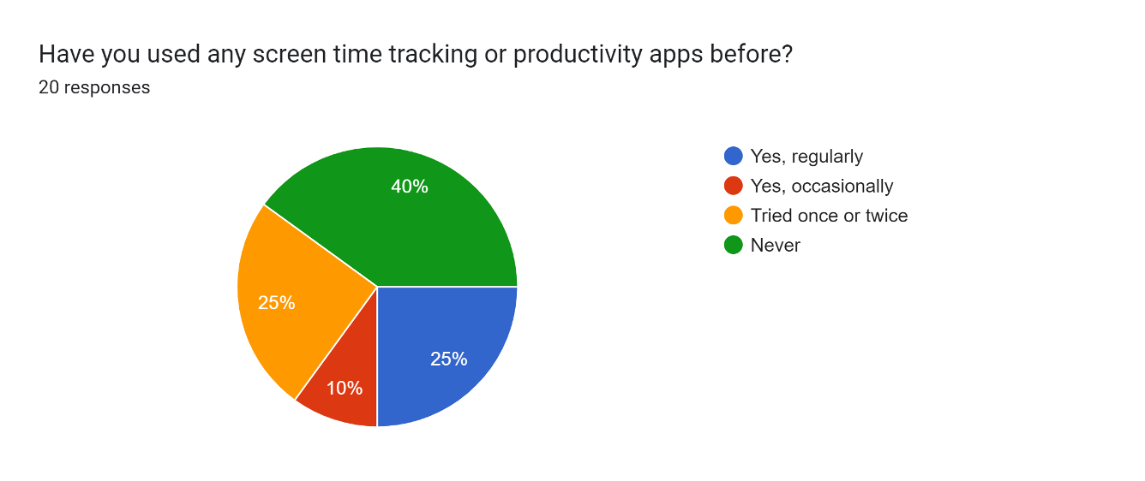

10 Fig 4.4: Pie chart displaying the responses to the question: "Have you used any screen time tracking or productivity apps before?"

Fig 4.4: Pie chart displaying the responses to the question: *"Have you used any screen time tracking or productivity apps before?"*

The chart you've provided is a pie chart displaying the responses to the question: *"Have you used any screen time tracking or productivity apps before?"* Here’s a detailed analysis:

**Analysis of Responses to Screen Time or Productivity App Usage:**

1. **Yes, regularly (Blue)**
   * **40%** of respondents use screen time tracking or productivity apps **regularly**.
   * This indicates that a significant portion of users consistently rely on apps to monitor and manage their screen time or improve productivity.
2. **Yes, occasionally (Red)**
   * **25%** of respondents use such apps **occasionally**.
   * This group may use the apps during certain periods, like when they feel the need to track time or boost productivity, but it’s not part of their regular routine.
3. **Tried once or twice (Orange)**
   * **25%** of respondents have **tried** screen time or productivity apps only once or twice.
   * This suggests that these users may not have found the apps sufficiently useful or relevant to continue using them on a regular basis.
4. **Never (Green)**
   * **10%** of respondents have **never** used screen time or productivity apps.
   * A small portion of users hasn’t explored these tools, possibly due to a lack of interest or not feeling the need for such apps.

**Insights:**

* **Frequent Usage**: **40% of users regularly use productivity or screen time apps**, showing a clear interest in actively managing their time and improving productivity.
* **Moderate Engagement**: **25% use the apps occasionally**, suggesting that these users might need reminders or motivation to engage with such apps.
* **Limited Interest**: **25% have only tried the apps once or twice**, which might indicate a lack of long-term engagement or effectiveness for some users.
* **Minimal Use**: **10% have never used these apps**, which could point to a portion of the population not yet motivated to track or optimize their phone use.

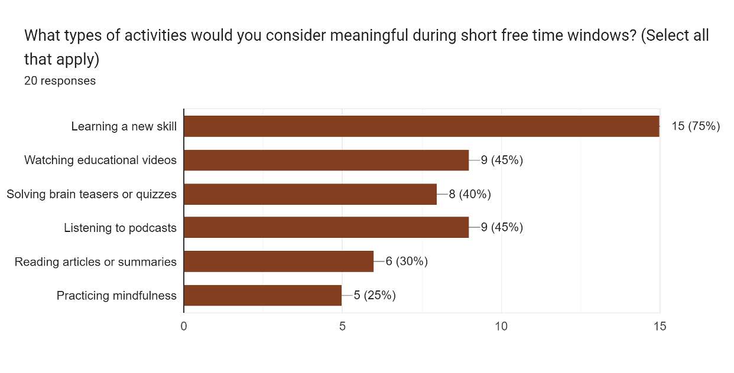

11 Fig 4.5: Bar chart showing the types of activities respondents consider meaningful during short free time windows.

Fig 4.5: Bar chart showing the types of activities respondents consider meaningful during short free time windows.

The chart you've provided is a bar chart showing the types of activities respondents consider meaningful during short free time windows. Here’s a detailed analysis:

**Analysis of Meaningful Activities During Short Free Time:**

1. **Learning a new skill (75%)**
   * **15 out of 20** respondents selected **learning a new skill** as the most meaningful activity.
   * This indicates that a significant portion of users values self-improvement and skill development during their free time.
2. **Watching educational videos (45%)**
   * **9 out of 20** respondents find watching educational videos meaningful.
   * This suggests that many users are inclined to use their free time for learning through video content, reflecting the growing trend of educational content consumption on platforms like YouTube
3. **Solving brain teasers or quizzes (40%)**
   * **8 out of 20** respondents prefer solving brain teasers or quizzes.
   * This indicates a preference for engaging the mind in intellectual activities that are both fun and challenging.
4. **Listening to podcasts (45%)**
   * **9 out of 20** respondents selected listening to podcasts as a meaningful activity.
   * Podcasts remain a popular medium for learning and entertainment during free time, as they allow users to multitask or listen while doing other activities.
5. **Reading articles or summaries (30%)**
   * **6 out of 20** respondents consider reading articles or summaries meaningful.
   * This suggests that a smaller but still significant group of users values consuming written content to stay informed or learn.
6. **Practicing mindfulness (25%)**
   * **5 out of 20** respondents find practicing mindfulness meaningful.
   * Although the smallest group, this indicates that some users prioritize mental well-being during their free time.

**Insights:**

* **Self-improvement is a priority**: The large percentage (75%) of respondents who value learning new skills highlights a strong inclination toward personal growth during free time.
* **Educational content consumption**: **Watching educational videos** and **listening to podcasts** are both significant activities, with **45%** of respondents selecting them. This indicates a preference for consuming content that adds value to their lives.
* **Mental engagement**: Activities like solving **brain teasers** or **quizzes** show that users enjoy keeping their minds sharp in short bursts.
* **Smaller focus on relaxation**: While mindfulness is important to a portion of respondents (25%), it's not as highly prioritized compared to other productive activities.

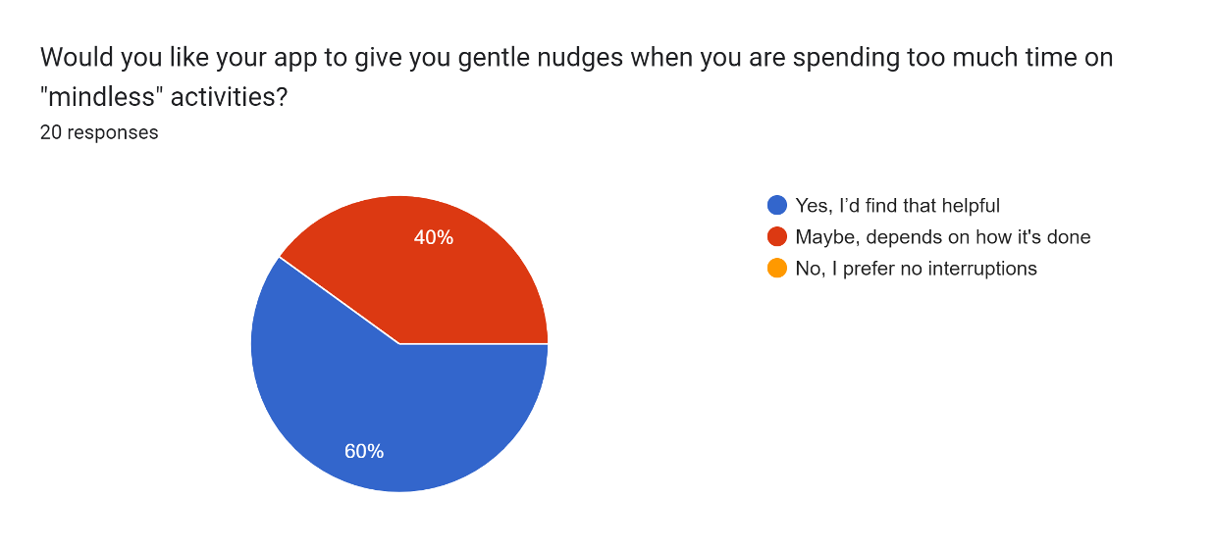

12 Fig 4.6: Pie chart showing the responses to the question: "Would you like your app to give you gentle nudges when you are spending too much time on 'mindless' activities?"

Fig 4.6: Pie chart showing the responses to the question: *"Would you like your app to give you gentle nudges when you are spending too much time on 'mindless' activities?"*

The chart you've provided is a pie chart showing the responses to the question: *"Would you like your app to give you gentle nudges when you are spending too much time on 'mindless' activities?"* Here’s a detailed analysis:

**Analysis of Responses to Nudges for Mindless Activities:**

1. **Yes, I’d find that helpful (Blue)**
   * **60%** of respondents said they would find **gentle nudges** helpful when spending too much time on mindless activities.
   * This shows that a significant portion of users would appreciate an app that offers reminders or suggestions to help them refocus or engage in more meaningful activities.
2. **Maybe, depends on how it's done (Red)**
   * **40%** of respondents are **unsure** but are open to nudges depending on the implementation.
   * This indicates that while users may be open to nudges, the approach, frequency, and manner of the reminders are crucial to their acceptance. This suggests a need for non-intrusive, context-aware notifications.
3. **No, I prefer no interruptions (Orange)**
   * **0%** of respondents said they prefer **no interruptions**.
   * This result shows that there was no group that outright rejects any nudging, which is a positive sign for designing such a feature, but it also indicates that users might be highly sensitive to the way these nudges are delivered.

**Insights:**

* **Strong Preference for Nudges**: **60%** of users would appreciate nudges, meaning that many users are willing to engage with gentle reminders that encourage productive habits.
* **Cautious but Open**: **40%** of respondents would be open to the idea but depend on how it’s implemented. This highlights the importance of customization and flexibility in the app’s notification settings to avoid user frustration.
* **No Objection to Nudging**: No respondents rejected the idea outright, suggesting that the concept of gentle nudges could be well-received if done correctly.

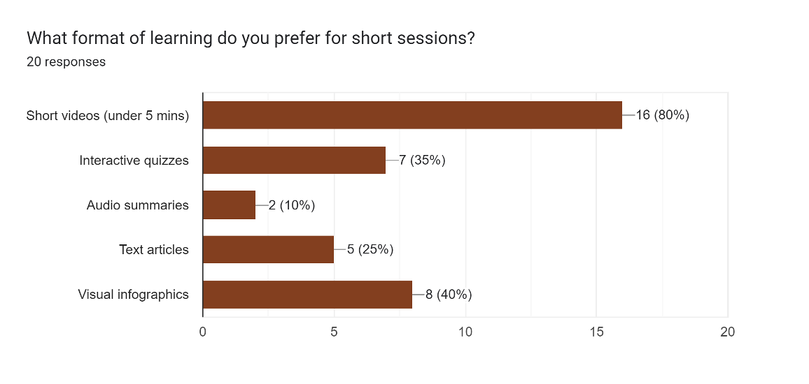

13 Fig 4.7: Bar chart showing the preferred formats for learning during short sessions.

Fig 4.7: Bar chart showing the preferred formats for learning during short sessions.

The chart you've provided is a bar chart showing the preferred formats for learning during short sessions, with a total of 20 responses. Here’s a detailed analysis:

**Analysis of Learning Format Preferences for Short Sessions:**

1. **Short videos (under 5 mins) (80%)**
   * **16 out of 20** respondents prefer **short videos** (under 5 minutes) for learning during short sessions.
   * This indicates that the majority of users favor quick, visual learning formats that can be consumed in a short amount of time, which is ideal for short breaks or idle moments.
2. **Interactive quizzes (35%)**
   * **7 out of 20** respondents prefer **interactive quizzes**.
   * This suggests that a significant portion of users enjoy actively engaging with content, reinforcing learning through quizzes or interactive elements.
3. **Visual infographics (40%)**
   * **8 out of 20** respondents prefer **visual infographics**.
   * Visual content that summarizes information effectively in a concise manner is preferred by a good portion of users, showing that users like to absorb information in a visually engaging format.
4. **Text articles (25%)**
   * **5 out of 20** respondents prefer **text articles**.
   * A smaller but notable group of users still prefers reading text-based content, which indicates some preference for detailed information that can be consumed during free time.
5. **Audio summaries (10%)**
   * **2 out of 20** respondents prefer **audio summaries**.
   * Audio-based content is the least preferred format, with only a small number of users finding it suitable for short learning sessions.

**Insights:**

* **Video Learning**: **Short videos** are overwhelmingly the preferred format, indicating that users favor a dynamic and visual approach to learning, particularly for short time windows.
* **Engagement and Interaction**: **Interactive quizzes** and **visual infographics** both enjoy moderate popularity, reflecting a desire for engaging and visually appealing content.
* **Text-Based Learning**: While **text articles** are still valued, they are less preferred compared to more interactive or visual content.
* **Audio Learning**: **Audio summaries** are the least popular, indicating that users may not find them as effective for short learning sessions.

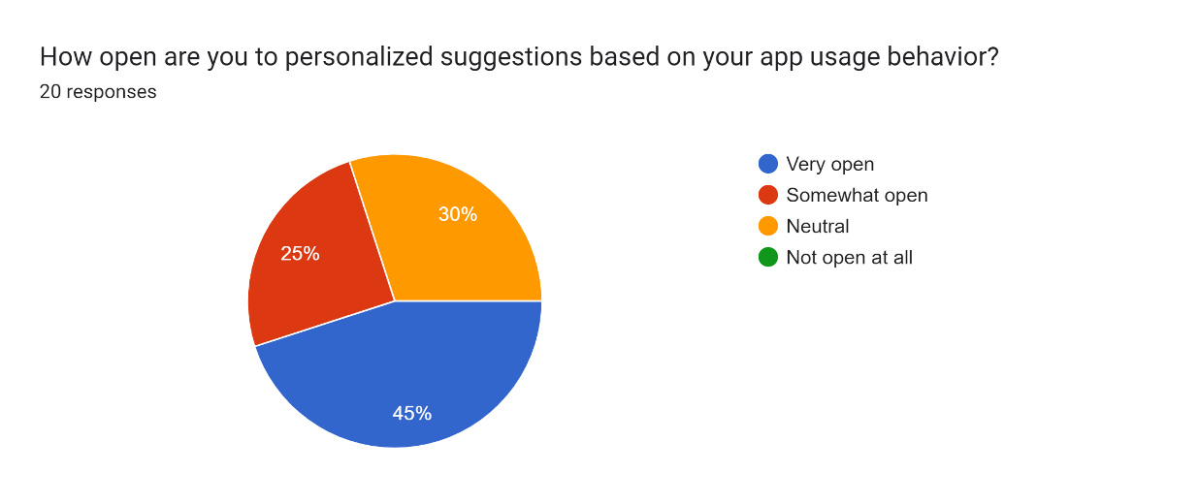

14 Fig 4.8: Pie chart showing the responses to the question: "How open are you to personalized suggestions based on your app usage behavior?"

Fig 4.8: Pie chart showing the responses to the question: *"How open are you to personalized suggestions based on your app usage behavior?"*

The chart you've provided is a pie chart showing the responses to the question: *"How open are you to personalized suggestions based on your app usage behavior?"* Here’s a detailed analysis:

**Analysis of Openness to Personalized Suggestions:**

1. **Very open (Blue)**
   * **45%** of respondents are **very open** to personalized suggestions based on their app usage behavior.
   * This indicates a strong willingness to receive personalized recommendations, which suggests that users value tailored experiences and improvements in app functionality based on their behavior.
2. **Somewhat open (Red)**
   * **25%** of respondents are **somewhat open** to personalized suggestions.
   * This group may appreciate personalized suggestions but could have concerns about the frequency, accuracy, or relevance of the suggestions. The willingness to receive suggestions is there, but with some reservations.
3. **Neutral (Orange)**
   * **30%** of respondents are **neutral** toward receiving personalized suggestions.
   * This suggests that a portion of users neither strongly accepts nor rejects personalized suggestions. They might be indifferent or unsure about the usefulness of such features, or they might have concerns about privacy or intrusiveness.
4. **Not open at all (Green)**
   * **0%** of respondents are **not open at all** to personalized suggestions.
   * No users outright rejected personalized suggestions, which is a positive indication that, in general, users are open to the concept of personalization, even if they have varying degrees of acceptance.

**Insights:**

* **Majority Open to Personalization**: **45%** of users are very open to personalized suggestions, highlighting that many users are eager for tailored experiences and value recommendations that align with their usage behavior.
* **Moderate Acceptance**: **25%** are somewhat open, showing that a portion of users are willing to receive personalized suggestions, but they might need some customization to avoid feeling overwhelmed or annoyed.
* **Neutral Stance**: **30%** are neutral, which suggests a need for thoughtful design in personalized suggestions to avoid alienating these users.
* **No Rejection**: The fact that no one is completely against personalized suggestions suggests that, with proper implementation, personalized nudges or recommendations could be widely accepted.

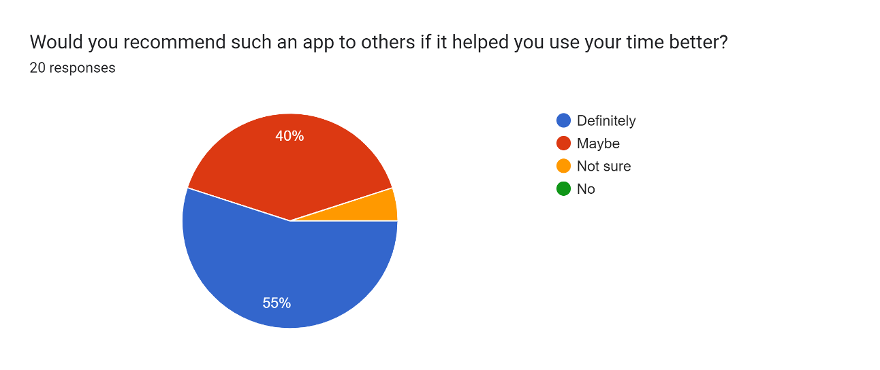

15 Fig 4.9: Pie chart showing the responses to the question: "Would you recommend such an app to others if it helped you use your time better?"

Fig 4.9: Pie chart showing the responses to the question: *"Would you recommend such an app to others if it helped you use your time better?"*

The chart you've provided is a pie chart showing the responses to the question: *"Would you recommend such an app to others if it helped you use your time better?"* Here’s a detailed analysis:

**Analysis of Willingness to Recommend the App:**

1. **Definitely (Blue)**
   * **55%** of respondents would **definitely recommend** the app to others if it helped them use their time better.
   * This indicates that a majority of users are enthusiastic about the potential benefits of the app and believe in its value, making them likely to recommend it to others.
2. **Maybe (Red)**
   * **40%** of respondents are **unsure** but would consider recommending the app depending on how it works for them.
   * This group might appreciate the app but could have reservations about its actual effectiveness or their personal experience with it. The uncertainty could also relate to factors like app usability or long-term value.
3. **Not sure (Orange)**
   * **5%** of respondents are **neutral** or **unsure** about recommending the app.
   * A small percentage of users are on the fence, possibly requiring more experience or confidence in the app's results to make a recommendation.
4. **No (Green)**
   * **0%** of respondents would **not recommend** the app.
   * This is a positive finding, indicating that no one outright rejected the idea of recommending the app, suggesting a broad appeal if it helps improve time management.

**Insights:**

* **Strong Recommendation Likely**: A **55%** majority would definitely recommend the app, signaling strong user satisfaction and potential word-of-mouth promotion.
* **Moderate Ambivalence**: **40%** of users are unsure, which could be due to varying expectations or experiences with the app. This group would likely need further testing and validation to be fully convinced.
* **No Rejection**: The **0%** in the "No" category suggests that there’s no strong opposition to the app’s idea, indicating that it holds broad appeal.

# Chapter 5: High Fidelity Prototyping

5.1 Figma Prototype URL: [Click Here to View Prototype](https://www.figma.com/design/fKnv0Nam9RqUgvvTWYFOBl/CSE428?node-id=0-1&t=3XO9yXwMkgaSQtgt-1)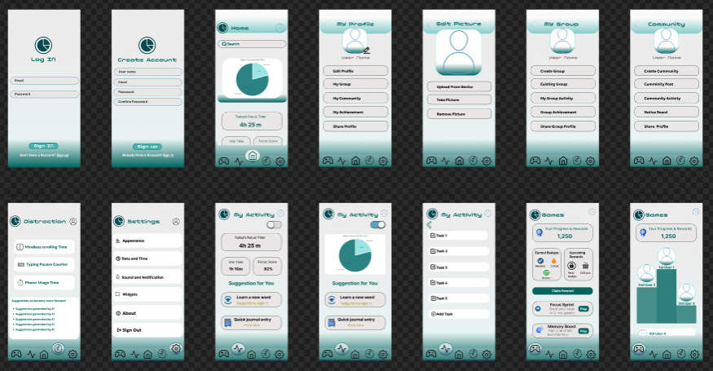

16 Fig 5.1: Overview of all pages

Fig 5.1: Overview of all pages

Link: [CSE428 – Figma](https://www.figma.com/design/fKnv0Nam9RqUgvvTWYFOBl/CSE428?node-id=0-1&p=f&t=ABXSx9NqebzbdeCG-0)

**1. Log In Screen**

* **Fields**:
  + **Email** and **Password** fields for the user to log into their account.
  + A **Sign In** button for logging in.
  + **Don't have an account? Sign Up** link for users to create a new account if they don’t already have one.

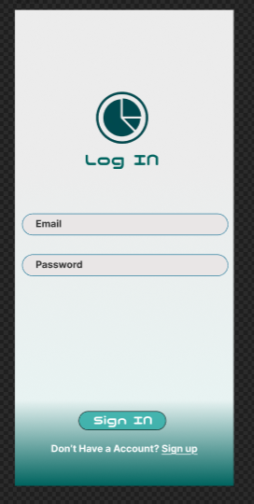

17 Fig 5.2: Login Page

Fig 5.2: Login Page

**2. Create Account Screen**

* **Fields**:
  + **Username**, **Email**, **Password**, and **Confirm Password** fields for creating a new user account.
  + A **Sign Up** button for account creation.
  + **Already have an account? Log In** link for users who already have an account.

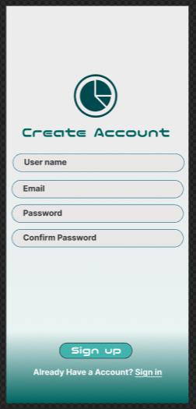

18 Fig 5.3: Create Account Page

Fig 5.3: Create Account Page

**3. Home Screen**

* **Main Content**:
  + Displays a **Productivity Pie Chart** showing the user’s current time management.
  + **Current Usage Time**: The total time the user has spent using the app or their device.
  + **Recent Activities** and a **Search Bar**.
  + Quick access to **Suggestions** and a summary of activity.

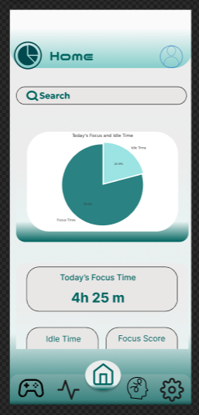

19 Fig 5.4: Home Page

Fig 5.4: Home Page

**4. My Profile Screen**

* **User Info**:
  + Shows the user’s **profile**, **username**, and **profile picture**.
  + Options to **Edit Profile**, upload pictures, and modify user details.
  + Access to the **Community**, **My Groups**, and **My Achievement** sections.

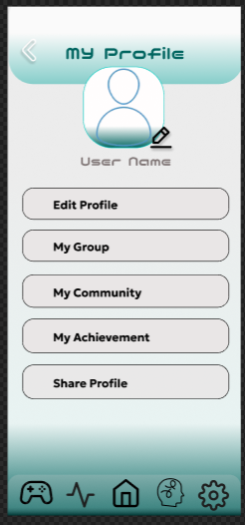

20 Fig 5.5: My Profile Page

Fig 5.5: My Profile Page

**5. Edit Profile Screen**

* **User Profile**:
  + Allows the user to upload a **profile picture**, update their **username**, and edit their **personal information**.
  + Option to **take pictures** or **upload from the device**.

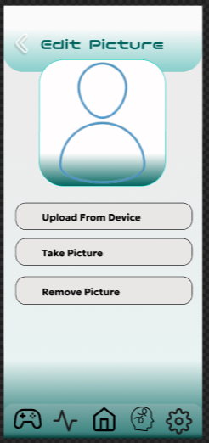

21 Fig 5.6: Edit My Profile Page

Fig 5.6: Edit My Profile Page

**6. My Group Screen**

* **Group Options**:
  + Users can **create** or **join** a group
  + View **existing group activities** and achievements.
  + **Group Profile** and **Group Activity** stats are available.

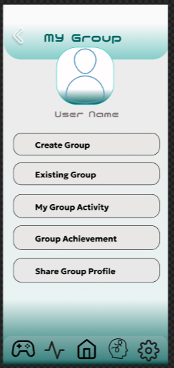

22 Fig 5.7: My Group Page

Fig 5.7: My Group Page

**7. Community Screen**

* **Community Features**:
  + Allows users to **create a community** or join an existing one.
  + View **community posts**, **group achievements**, and **community activity**.
  + User profile and **social engagement options**.

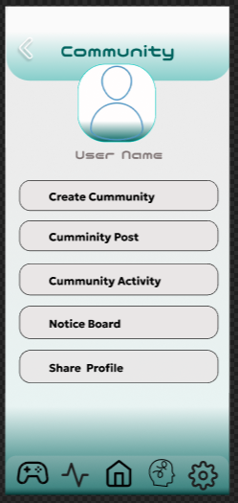

23 Fig 5.8: My Community Page

Fig 5.8: My Community Page

**8. Distraction Screen**

* **Tracking Distractions**:
  + Allows the user to monitor different types of distractions such as **phone pick-ups**, **typing pauses**, and other activities that impact productivity.
  + Displays relevant insights for each distraction type.

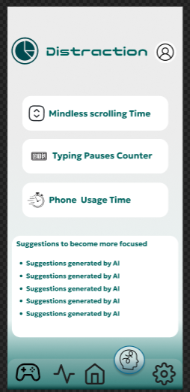

24 Fig 5.9: Distraction Page

Fig 5.9: Distraction Page

**9. Settings Screen**

* **User Preferences**:
  + Allows users to adjust **appearance settings**, **data sync options**, and **sound/notification preferences**.
  + Includes options for **widgets** and settings like **sign-out** or **app permissions**.

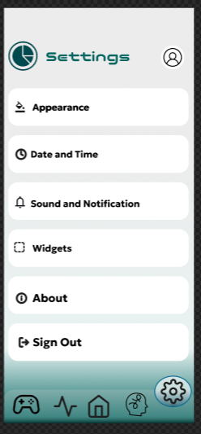

25 Fig 5.10: Setting Page

Fig 5.10: Setting Page

**10. My Activity Screen**

* **Activity Summary**:
  + Displays the user’s **current activity** and breaks down the activities into productivity or focus time.
  + Provides a **pie chart** or graphical representation of activity levels.
  + Includes **suggestions for better use** of time based on activity patterns.

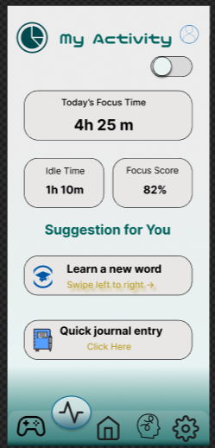

26 Fig 5.11: My Activity Page

Fig 5.11: My Activity Page

**11. Suggestion Screen**

* **Personalized Recommendations**:
  + Provides **suggestions** for activities such as learning tasks, games, podcasts, or other entertainment to improve the user’s engagement with the app.
  + **Quick Activity** options for engaging users in quick productivity tasks.

**12. Games Screen**

* **Gamification Section**:
  + Displays the **user’s progress** in productivity and rewards system (e.g., **user productivity score**, **achievement badges**, **leaderboard**).
  + Displays **social sharing buttons** for users to share progress with friends.

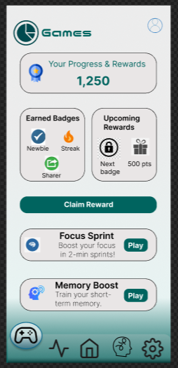

27 Fig 5.12: Game Page

Fig 5.12: Game Page

**13. Progress & Rewards Screen**

* **Gamification & Rewards**:
  + **User productivity score** and **progress bar** are shown.
  + **Reward badges** or achievement points based on performance in tasks.
  + **Social sharing buttons** to allow users to share achievements.

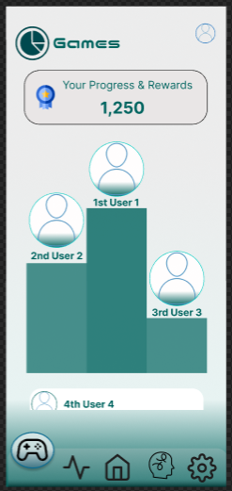

28 Fig 5.13: Leaderboard Page

Fig 5.13: Leaderboard Page

**General App Design Features:**

* **Color Scheme**: The app uses a calming color palette, with shades of teal and white, suggesting a clean and modern design with an emphasis on user-friendly navigation.
* **Navigation**: Clear **navigation buttons** at the bottom of the screen for easy access to all app sections, including Home, Distractions, Settings, Profile, and Games.
* **User Engagement**: The app integrates **gamification elements**, such as productivity scores and badges, to encourage continuous interaction.

5.2 Style Guide:

* + **Typography**: Use of modern, sans-serif fonts Nico Moji and Inter for legibility and a clean appearance.
  + **Color Scheme**: Simple yet engaging color palette to highlight key features and maintain focus, with strong contrast for visibility.

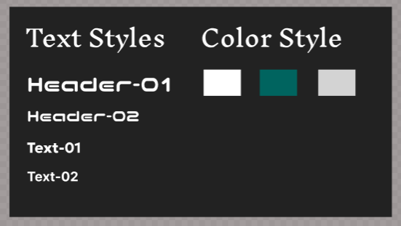

29 Fig 5.14: Style Guide Fontd and Colors.

Fig 5.14: Style Guide Fontd and Colors.

**Navigation Bar:**

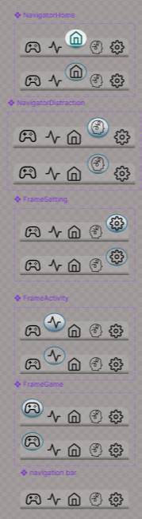

30 Fig 5.15: Navigation Bar

Fig 5.15: Navigation Bar

**Screen Scroll Component:**

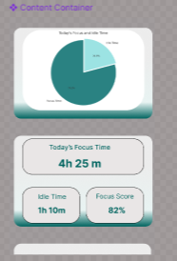

31 Fig 5.16: Screen Scroll Component

Fig 5.16: Screen Scroll Component

**Leaderboard Components:**

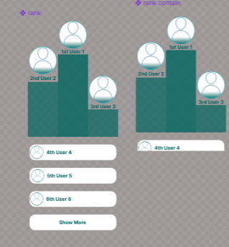

32 Fig 5.17: Leaderboard Components

Fig 5.17: Leaderboard Components

**All Components:**

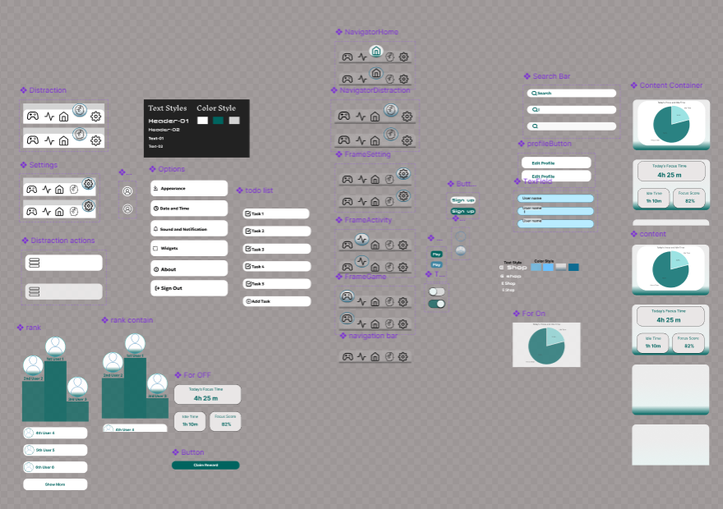

33 Fig 5.18: All Components

Fig 5.18: All Components

# Chapter 6: Interface Evaluation

## 6.1 Heuristic Evaluation

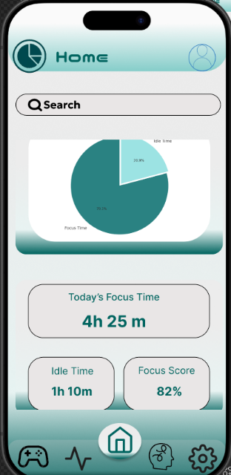**Problem:**The pie chart’s labels ("Focus Time" and "Idle Time") are small, making it difficult to read and interpret the data. Also, the search bar is not clearly distinguishable as interactive due to minimal visual affordance.

34 Fig 6.1: Home page

**Heuristics:**#1 Visibility of system status (chart data not clear)  
#6 Recognition rather than recall (poor label visibility)  
#4 Consistency and standards (search bar lacks standard affordance)

**Severity:** Major

**Recommendation:**

Increase font size and ensure all chart labels fit fully within the chart area. Add tooltips or legends for clearer data interpretation. Make the search bar more interactive-looking with stronger borders, shadows, or a clearer input field style.

Fig 6.1: Home page

**Evaluation based on Graphics Design Principles:**

**Contrast:** The contrast is good between the "Focus Time" and "Idle Time" sections. However, the pie chart could use stronger contrast in the chart labels.

**Repetition:** The buttons have a consistent layout, but the design can use more repeated elements for visual harmony.

**Alignment:** The elements (pie chart and buttons) could be aligned better. Right now, everything is a bit scattered.

**Proximity:** The "Focus Time" and "Idle Time" are close, but the "Focus Score" and "Idle Time" section can be placed closer together for better grouping.

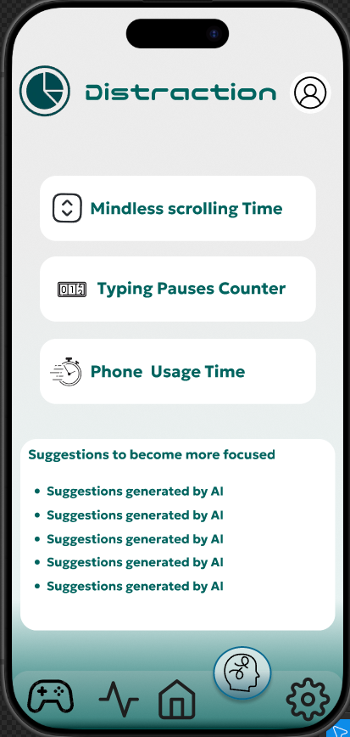**Problem:**  
The spacing and alignment between the icons and text on the buttons are uneven, making the buttons look less refine.

35 Fig 6.2: Distraction page

**Heuristics:**  
#4 Consistency and standards (uneven spacing on buttons)

**Severity:** Minor

**Recommendation:**

Align the icons and text inside the buttons evenly for a cleaner look.

**Evaluation based on Graphics Design Principles:**

**Contrast**: The buttons and icons are clear, but the “Suggestions” text blends in with the background. It could use more contrast.

Fig 6.2: Distraction page

**Repetition**: The button style is repeated throughout, creating visual consistenc

**Alignment**: The icons are slightly misaligned with the text, which makes it feel uneven.

**Proximity**: The buttons are grouped well, but the "Suggestions" section could be closer to the action buttons for better organization.

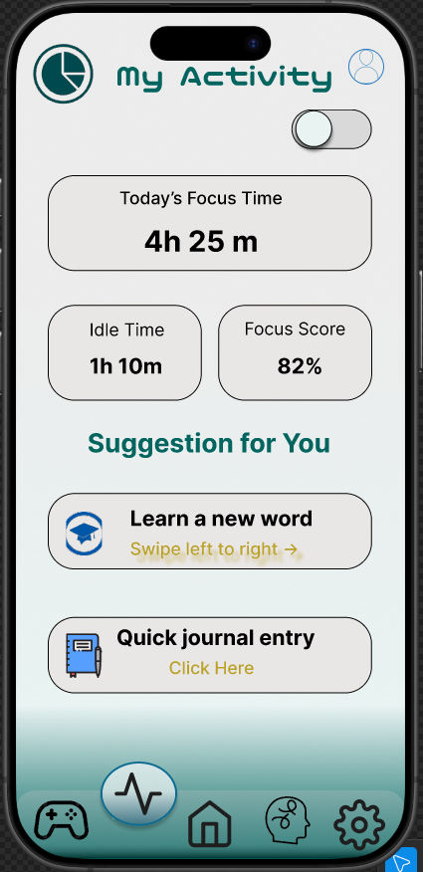**Problem:**  
The toggle switch at the top right is unclear about what it controls because there is no label or explanation next to it. Also, the instructions for actions ("Swipe left to right" and "Click Here") are small and low contrast, making them hard to notice.

36 Fig 6.3: My activity page

**Heuristics:**  
#1 Visibility of system status (toggle purpose unclear)  
#6 Recognition rather than recall (small, faint action instructions)  
#8 Aesthetic and minimalist design (low contrast text)

**Severity:** Minor

Fig 6.3: My activity page

**Recommendation:**

Add a clear label or tooltip near the toggle switch to explain what it does. Make the action instructions bigger and use higher contrast colors so users can easily see what to do.

**Evaluation based on Graphics Design Principles:**

**Contrast**: The contrast is good in general, but the "Today’s Focus Time" could stand out more compared to the rest of the data.

**Repetition**: The layout and button styles are repeated, but they could be more consistent in size and placement.

**Alignment**: Some elements like the chart and text are not perfectly aligned, making it feel a little unorganized.

**Proximity**: The “Suggestion for You” section feels a bit far from the other stats, making it harder to connect with the main content.

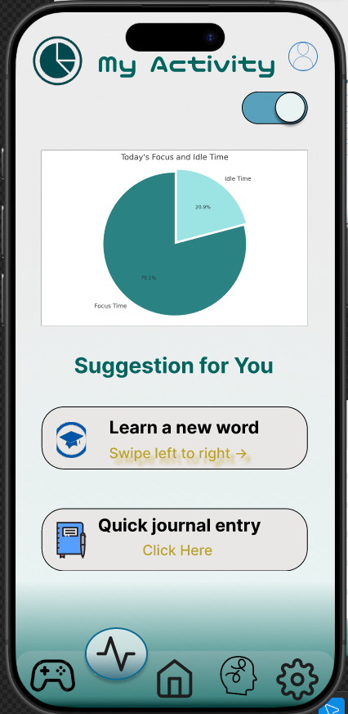**Problem:**  
The pie chart is too small and the text inside the chart is hard to read because of the small font size. The switch at the top right is better now but still no label explaining what it controls. The action instructions below the buttons are still low contrast and hard to notice.

**Heuristics:**  
#1 Visibility of system status (small chart text)  
#6 Recognition rather than recall (no switch label, faint action instructions)  
#8 Aesthetic and minimalist design (small chart, low contrast text)

**Severity:** Major

Fig 6.4: My activity page

**Recommendation:**

Make the pie chart larger and increase the font size of labels inside the chart for easy reading. Add a clear label near the switch to explain its function. Use darker or more contrasting colors for the “Swipe left to right” and “Click Here” texts.

37 Fig 6.4: My activity page

**Evaluation based on Graphics Design Principles:**

**Contrast**: The chart’s contrast is fine, but the text inside the chart is hard to read due to small size.

**Repetition**: The layout is consistent with the previous screen, but the button text could use some variation in size for more focus.

**Alignment**: The pie chart and text are not well-aligned, making it feel like the data is slightly off-balance.

**Proximity**: The “Suggestions for You” section should be placed closer to the pie chart or have better spacing to avoid feeling disconnected.

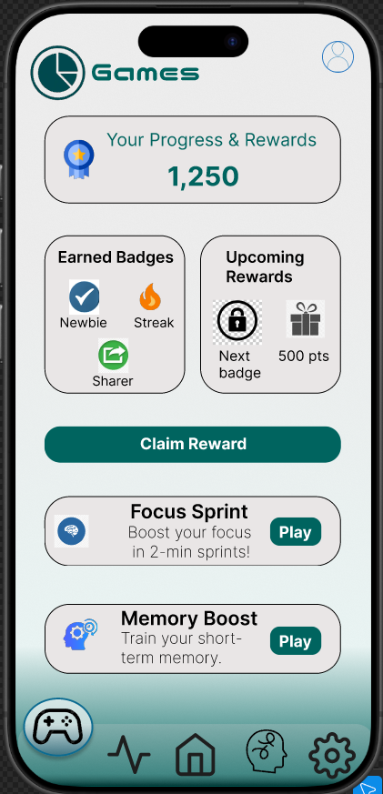**Problem:**  
The "Claim Reward" button is not very eye-catching because it looks similar to other buttons. Also, the badges and rewards section lacks clear separation, making it a bit confusing to quickly understand what’s earned and what’s coming next.

**Heuristics:**  
#8 Aesthetic and minimalist design (button and layout clarity)  
#6 Recognition rather than recall (confusing grouping of badges and rewards)  
#4 Consistency and standards (button styling inconsistency)

**Severity:** Minor

38 Fig 6.5: Game page

**Recommendation:** Fig 6.5: Game page

Make the "Claim Reward" button more prominent by using a brighter color or bigger size. Separate the "Earned Badges" and "Upcoming Rewards" sections more clearly with spacing or borders. Keep button styles consistent across the screen for a cleaner look.

**Evaluation based on Graphics Design Principles:**

**Contrast**: The “Claim Reward” button stands out well, but the text inside the “Upcoming Rewards” section could be clearer with stronger contrast.

**Repetition**: The design repeats button styles, but the icons could be slightly larger to create more emphasis.

**Alignment**: The items in the progress section are aligned well, but the text and icons inside the buttons could be better aligned.

**Proximity**: The "Earned Badges" and "Upcoming Rewards" sections are well grouped, but they could use a little more space between each for better clarity.

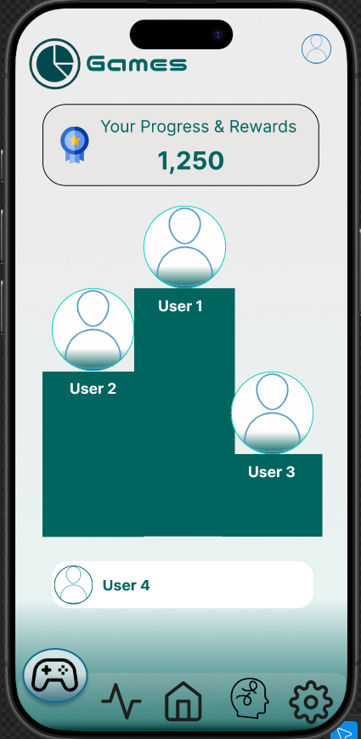**Problem:**  
The leaderboard chart is confusing because the size of the blocks does not clearly show the difference between users’ ranks or scores. The user images and names overlap the blocks, making it harder to read.

39 Fig 6.6: Leaderboard page

**Heuristics:**  
#6 Recognition rather than recall (confusing ranking display)  
#8 Aesthetic and minimalist design (overlapping elements)  
#4 Consistency and standards (standard leaderboard format missing)

**Severity:** Major

**Recommendation:**

Use a clearer leaderboard format, such as a simple vertical list with ranks and scores. Avoid overlapping images and text on blocks. Instead, place user images and names clearly beside or above their rank. Use size or color differences clearly to show ranking. Fig 6.6: Leaderboard page

**Evaluation based on Graphics Design Principles:**

**Contrast**: The leaderboard blocks are hard to differentiate; adding more contrast in size or color between users would help.

**Repetition**: The user icons are repeated but don't stand out enough to show rankings clearly.

**Alignment**: The elements are misaligned, especially the names of users and their respective ranks.

**Proximity**: The "User" names are placed far from their blocks, making the ranking feel disconnected.

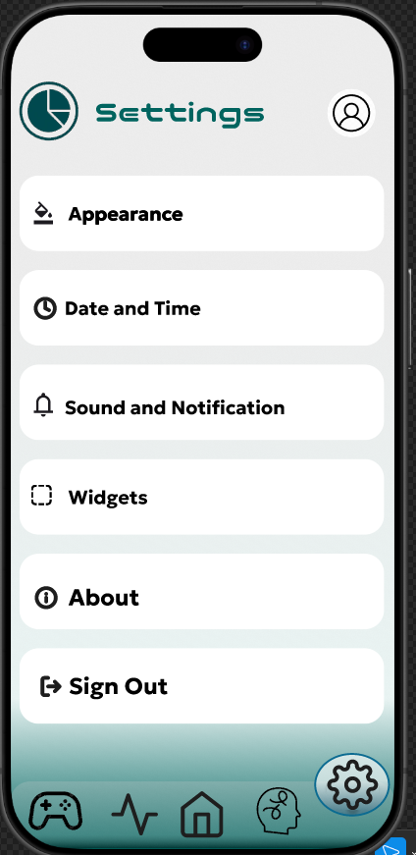

40 Fig 6.7: Setting page

**Problem:**  
The menu items icons and text are not vertically aligned properly.

**Heuristics:**  
#8 Aesthetic and minimalist design (inconsistent text style and alignment)  
#6 Recognition rather than recall (alignment affects quick reading)

**Severity:** Minor

**Recommendation:**

Align icons and text vertically so they line up nicely in each row for better readability.

Fig 6.7: Setting page

**Evaluation based on Graphics Design Principles:**

**Contrast**: The contrast is good in most areas, but the icons and text on the buttons could be stronger for easier readability.

**Repetition**: The button styles are consistent, but the text could be more uniform across all sections.

**Alignment**: The icons and text in the buttons are not perfectly aligned, which makes the design look a little off.

**Proximity**: The sections are well-spaced but could use slightly more space around the "Sign Out" button for better balance.

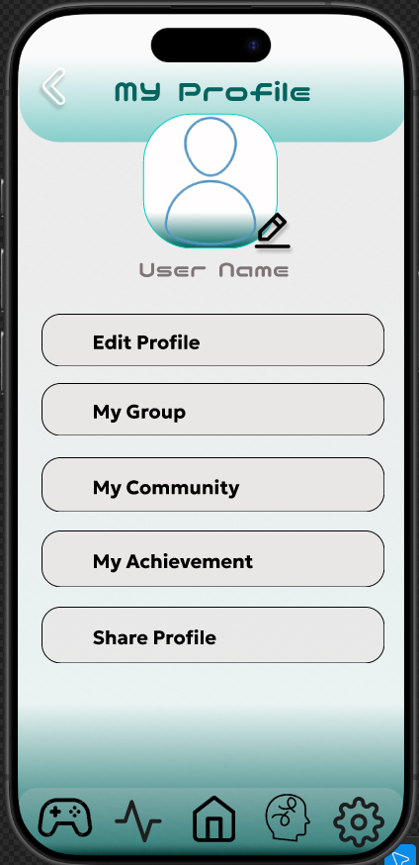

41 Fig 6.8: My profile page

**Problem:**  
The text below the profile picture ("User Name") uses a hard-to-read font that looks different from the rest of the app. Also, the pencil icon on the profile picture is small and not very clear as an edit button.

**Heuristics:**  
#8 Aesthetic and minimalist design (inconsistent font style)  
#6 Recognition rather than recall (unclear edit icon)  
#4 Consistency and standards (font style differs from rest of app)

**Severity:** Minor

**Recommendation:**

Use a font style for the username that matches the rest of the app and is easy to read. Make the pencil icon bigger and clearer, or add a label like “Edit” to show its function.

Fig 6.8: My profile page

**Evaluation based on Graphics Design Principles:**

**Contrast**: The contrast is okay but could be improved in the "User Name" section to make it stand out more.

**Repetition**: The button layout is repeated nicely, but the edit icon for the profile picture is too small and not very visible.

**Alignment**: The elements are well-aligned, but the profile picture text (“User Name”) could use more consistent font styling.

**Proximity**: The profile section is well grouped, but the buttons could be placed closer together to create a better flow.

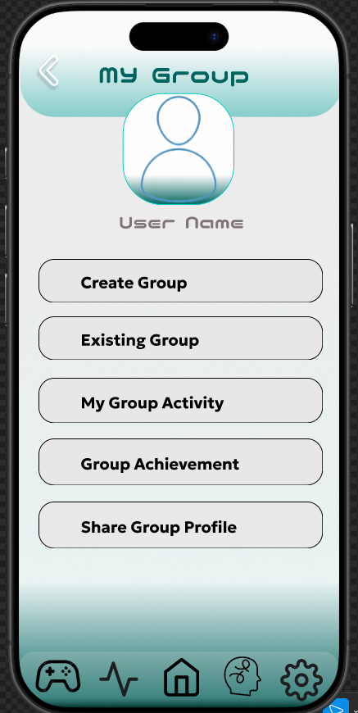**Problem:**  
The profile name text ("User Name") is inconsistent in font style, which breaks the visual flow.

**Heuristics:**  
#8 Aesthetic and minimalist design (font style inconsistency)

**Severity:** Minor

**Recommendation:**

Make sure the font for the profile name matches the rest of the app for consistency and readability.

**Evaluation based on Graphics Design Principles:**

Fig 6.9: My Group page

**Contrast**: The "Exiting Group" button has a typo, making the contrast feel less clear and causing confusion.

42 Fig 6.9: My Group page

**Repetition**: The button layout is consistent, but the button sizes and placement could be slightly more uniform.

**Alignment**: The elements are aligned, but the text and icon size for the buttons could be better balanced.

**Proximity**: The buttons are well grouped, but the "User Name" text could be placed more closely to the profile picture.

# Chapter 7: Conclusion

Throughout the development of this project, several key insights emerged. One of the primary learnings was the sensitivity of idle behavior among users. It became evident that perceptions of idle time vary significantly from person to person, depending on factors such as mood, context, and routine. This highlighted the importance of incorporating personalized suggestions within the system, allowing the application to adapt to individual needs and expectations. Another important finding was the effectiveness of micro-engagement strategies. Users responded positively to short, simple activities that helped them make productive use of their idle time without feeling overwhelmed or pressured.

Despite these promising outcomes, the project faced certain limitations. Firstly, the current prototype does not support physiological tracking, such as monitoring heart rate or brain activity (e.g., via EEG), which could have provided deeper insights into user states and distractions. Secondly, the user testing pool was relatively small, limiting the diversity of feedback and reducing the ability to generalize findings across broader user groups.

Looking forward, future iterations of this project aim to address these limitations. The integration of wearable sensors will enable the collection of richer behavioral and physiological data, leading to more accurate and context-aware idle time detection. Additionally, the project plans to conduct broader and more diverse user testing, ensuring a more comprehensive understanding of user needs, preferences, and engagement patterns. These steps will help refine the system further and enhance its impact on digital well-being and productivity.

# Appendices

### Appendix A: Survey Responses

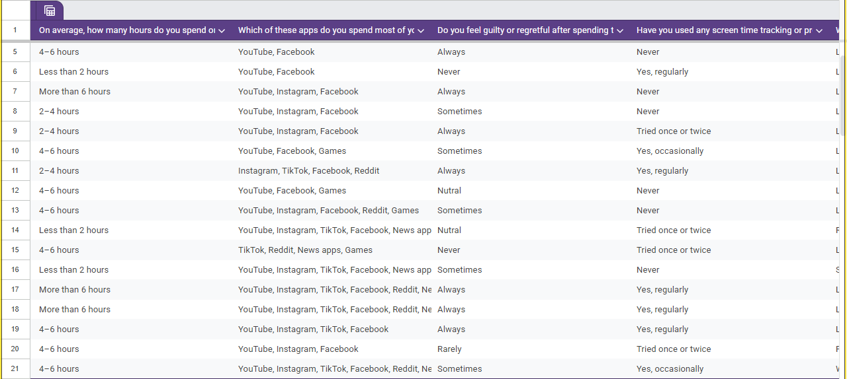

### Appendix B: Sketches and Wireframes



### Appendix C: Figma Prototype Screenshots

